History Colorado - Office of Archaeology and Historic Preservation
Colorado Cultural Resource Survey

Historic Archaeological Component Form Instructions

This form should be completed for each historical resource with archaeological potential and attached to a completed Management Data Form. Additional copies of the form may be used to describe individual features. Please note at the top of the form if the form pertains to the historical archaeological component in general or to a particular feature. Please see the Colorado Cultural Resource Survey Manual for detailed information concerning many of these categories.

1. Resource Number: Please put the resource number (Smithsonian trinomial number) here, as it appears on the Management Data Form.

2. Temporary Resource Number: List any temporary numbers assigned in the field.

3. Site Name: Please put the site name here, as it appears on the Management Data Form.

4. Site or Feature: Check if this form pertains to the entire site in general. If no, please supply a feature/structure number or name to which the form applies.

5. Site, Component, or Feature Type: Describe the type of site/feature, specifying function if known. Examples of site, component, or feature types can be found in Appendix A of these instructions.

6. Narrative History: The narrative history should be focused on the history of this property and directly pertain to the property's historic significance and integrity. The description should include both a synthesis of the artifacts and features and any additional important information. You may wish to complete parts 19, 22, and 24 before writing this section. Please see National Register Bulletin: How to Complete the National Register Registration Form page 47, http://www.nps.gov/nr/publications/bulletins/nrb16a/

This narrative is the most important section of the form. Please be as complete as possible.

7. N.R.H.P. Historic Landscape: Indicate, by checking the appropriate box, whether the resource is located in a cultural or historic landscape. A cultural landscape is defined as "a geographic area, including both cultural and natural resources and the wildlife or domestic animals therein, associated with a historic event, activity, or person or exhibiting other cultural or aesthetic values." There are four general types of cultural landscapes, which are not mutually exclusive: historic sites, historic designed landscapes, historic vernacular landscapes, and ethnographic landscapes. (see http://www.nps.gov/nr/publications/bulletins/nrb30/nrb30_8.htm - National Register Bulletin 30 Guidelines for Evaluating and Documenting Rural Historic Landscapes for more information).

8. Component or Feature Description: If the form pertains to a particular component or feature of the overall site, please describe it here in full. Be as specific as possible concerning the component or feature function, and location within the overall site.

9. Historic Component Date(s) and/or Sociopolitical Period: Give date or range of dates of the historic component, being as specific as possible (e.g., 1810-1830, rather than the early 1800s). It may be appropriate to also reference the sociopolitical period (The Depression, The Civil War, etc.) corresponding to these dates here. Describe the criteria used to date the site (e.g., diagnostic artifacts, patent dates, map). Provide the citation for the source(s) where data was gathered.

10. Component Function(s): If possible, identify the original and present uses of the site, being as specific as possible. If the site has been abandoned, indicate that in present use. If a site has had multiple uses or has multiple components with different uses, please elaborate.

11. Ethnic Affiliation of Occupants: When known, indicate the ethnic affiliation of site occupants (e.g., Euroamerican, Hispanic, etc.). The preference is for “Historic” for generic historic cultural affiliation over “Euroamerican” (or its variants). Although “Historic” is not a culture it is recommended as a placeholder that demonstrates that consideration of culture has taken place. In cases where an ethnic affiliation has been identified though historical records or site elements, the culture should be identified by country of association such as Germany, other comparable ethnic identifier (such as Basque, Hispanic, or African American), or Native American group. Describe the criteria you used to determine affiliation (e.g., artifacts or architectural features, historic references, etc.)

12. Historic Boundary: Select boundaries that encompass the entire resource, with historic and contemporary additions. Include any surrounding land historically associated with the resource that retains its historic integrity and contributes to the property's historic significance. The historic boundary may not match the legal property ownership.

For more information on historic boundaries, see:
http://www.historycolorado.org/sites/default/files/files/OAHP/Programs/SI_CameraClipboard24.pdf
13. N.R.H.P. Area of Significance: List the aspect of historic development in which this property made contributions for which it meets the National Register criteria, such as agriculture or politics/government. See http://www.nps.gov/nr/publications/bulletins/nrb16a/nrb16a_III.htm#statement for a listing of areas of significance. Provide the citation for the source(s) where data was gathered.

14. N.R.H.P. Period of Significance: List the span of time in which a property attained the significance for which it meets the National Register criteria. This could be a specific date or a date range. A property can have multiple periods of significance based on the appropriate areas of significance. If this is the case, list the multiple periods of significance. Provide the citation for the source(s) where data was gathered.

15. Theme: List the themes found in Appendix A of this document that pertain to the site.

16. Eligibility Support: If you are using this component form to document only a portion of the site, please check whether or not the portion you are recording supports the N.R.H.P. eligibility of the entire site. Justify your selection below. If you are using this component form to record the site in its entirety, check the N/A box.

17. Recorder(s): Enter the full name of the recorder(s). Do not use initials.

18. Date: Enter the last day that you were in the field. The date should be in a MM/DD/YYYY format.

19. Presence and Quantity of Artifacts: Use this table to denote what artifacts you are seeing, and how many. Note that many of the artifact types have dates associated with them. Use approximations for large quantities of artifacts. Use this information to help you fill out field 9 above.

20. Assemblage Size: Enter the total number of artifacts on the site, or check the appropriate estimated box.

21. Artifact Density: Check high, medium or low for artifact density. In description, indicate if there are differences in artifact distribution (e.g., heavy in some areas and light in other areas).

22. Unique Artifact Descriptions: List specific artifact types and the important attributes in the description field. The form contains prompts concerning the important descriptors for each artifact class. All of these items should be included in the counts of the Artifact table above in item 19 – Presence and Quantity of Artifacts. This gives you the opportunity to call attention to the really cool stuff.

For a detailed discussion of the different artifact classes and their important diagnostic characteristics, please see Appendix B, Historic Artifact Handbook, to these instructions. It will be very helpful to those inexperienced in recording historic archaeology sites and you are encouraged to consult it.

23. Standing structures: Indicate whether or not there are standing structures on the site. If there are, please complete an Architectural Inventory Form(s) (OAHP 1403) in addition to this form. If there is enough of the structure left to describe its architectural features (e.g., architectural style, number of stories, or presence of chimneys, doors, windows, etc.) you should also complete an Architectural Inventory Form(s).

If you complete an Architectural Inventory Form(s) please reference them here. You don't need to repeat any descriptive data that is redundant to the 1403 forms.

24. Features: List and describe each feature on the site. Be as specific as possible about function (e.g., is trash related to domestic or construction activities? Use cabin or barn vs. structure). In the case of trash scatters, artifacts should also be accounted for under the artifact section(s) of this form. The "Feature/Number Name" is a symbol or identification number referring to a feature on the sketch map.

For architectural features, include available information on construction material (e.g., wood, stone, etc.) and feature dimensions (preferably in feet and inches rather than metric). Include building footprint or groundplan here when it is discernible.

25. Archaeological Potential: Note whether or not there is the potential for archaeological deposits. If there is, describe the location and summarize the potential nature, depth, and research potential for those deposits. If it is unknown, document those areas that might have potential, which only further work would confirm.
Appendix A
List of Themes, Site Components and Features to consider when filling out the Historical Archaeological Component Form.

Theme
Subtheme
-Delineator

Historic Native American
(Named Native American Group)
Transportation
Trail
Road
Railroad

Water Control and Distribution
Dam
Head
Works
Canal
Ditch
Flume
Pipeline
Siphon

Communication
Telegraph
Telephone

Settlements
Household
Camp
Town
Company Town
Plaza
Rural Agriculture
Farming
Ranching
Industry
Fur and Hide Trade
Mining and Mineral Processing
-Stone Quarrying
-Cement
-Smelting
-Coal
-Uranium
-Placer Mining
-Precious Metals and Industrial Minerals Mining
Industry (cont.)
Timber
Food Processing
-Meat
-Dairying
-Sugar Beet
-Fresh Produce: Fruits and Vegetables
-Grains and Milling
-Canning and Bottling of Agricultural Produce
-Beverage
Oil and Gas
Oil Shale
Electrical Generation
-Water-powered
-Gas, Coal, or Nuclear-powered
-Wind-powered
-Solar
Steel and Iron
Chemical Manufacturing
Non-Metallic Mineral Products
-Brick
-Concrete and Cement
-Stone Finishing
-Cans, Bottles, and Stone Manufacture
Transportation and Freighting (e.g., automobile or wagon manufacturers or sites associated with freighting business)
Arms and Ammunition
Textile Working
Leather Products (e.g., saddle, harness, or clothing manufacture)
Rubber and Plastic Products
Other Specialized Manufacturing

Recreation
Outdoor
Government Managed
Health Resorts
Entertainment: Civic and Seedy
Social and Industrial (Corporate)
Developed Sport Auto and Railroad

Government
Exploration
Land Survey and Distribution
Indian Agencies
U.S. and State Military
Land Management
Public Works
Public Service
Transportation (for sites associated with government policy or funding)

Ethnicity (Use only as an adjunct to another theme or alone only if another theme cannot be identified)
Named ethnic group

Unknown
(May have subthemes associated with it)

Features

Adit
Air shaft
Artifact scatter (trash scatter, trash
dump)
Basement
Beacon
Berm
Bridle path
Bridle trail (use bridle path)
Cairn (purposeful stone marker)
Campfire ring (use hearth)
Campsite
Cemetery
Chute (log, ore)
Cinder pile
Construction debris (brick, stone,
lumber)
Cribbing
Depression
Drinking fountain
Dump
Farm equipment
Fence
Fire hearth (use hearth)
Fire pit (use hearth)
Fire ring (use hearth)
Fireplace
Flag pole
Foundation
Fur press
Game-hanging rack
Grave
Grave marker
Hearth
Hunting blind
Inscription (on tree or stone)
Marker
Mill tailings (use tailings)
Mine shaft
Outhouse hole
Oven (bread)
Path
Peeled tree
Penstock (pipeline used to transport water, usually under pressure)
Picnic table
Pipeline
Pit
Playing field
Pond
Pool (swimming, hot
springs)
Portal
Post (upright piece of wood, metal, or concrete)
Prospect hole (use prospect pit)
Prospect pit
Quarry
Ramp
Reservoir
Retaining wall
Rifle pit
Rock alignment
Rock art (without writing)
Rock pile (not cairn)
Sawdust pile
Sign
Slag pile
Soil stain (use surface stain)
Spring development
Stock tank
Stone circle
Stone quarry (use quarry)
Surface stain
Tailings
Tailings pile (use tailings)
Tent platform (use campsite)
Tent site (use campsite)
Tipi ring (use stone circle)
Tramway (aerial, cable,
funicular)
Trash disposal pit (use pit)
Trash dump (use artifact scatter or dump)
Trash scatter (use artifact scatter)
Tree art (without writing)
Trench
Tunnel (two open ends)
Vision quest
Walkway
Wall
Waste rock
Water fountain (use drinking fountain)
Water wheel
Well (lined hole or pipe)

Site Component or Feature Type

Administration building
Airfield
Airport
Amphitheater
Art gallery
Art studio
Assay office
Auto dealership
Auto showroom (use auto dealership)
Camp (CCC, construction, health, internment, logging, lumber, military, mining, mobilization, organization, stock, training)
Campfire circle (use amphitheater)
Campground (use camp)
Campsite (use camp)
Canal/Ditch
Cannery
Cantonment (use military camp)
Carriage works
Casino (use gambling hall)
Clubhouse
Coal washery
Coke oven
Communication building
Communication tower
Communication line
Community building
Company office (use office)
Country club
Creamery
Dairy
Dam
Depot (bus, railroad, freight)
Distillery
Ditch (use canal/ditch)
Dock (loading, boat)
Dormitory
Dude ranch
Elevator (grain or other product)
Entrance gate
Factory (munitions, sugar, other industries)
Fairground
Farm
Fire lookout
Fire watch tower (use fire lookout)
Fish hatchery
Fitness club (use health club)
Flume
Food locker (cold storage)
Fort (use fortification)
Fortification
Foundry (lead, steel, iron)
Fueling facility (usually use service station)
Gambling hall
Garden
Gas station (use service station)
Gazebo
Golf course
Grade (use railroad or road)
Grange hall (use community building)
Gristmill
Guard station
Gymnasium
Hall (concert, dance, dining, music, recreation)
Hangar
Health club
Highway (use road)
Homestead (if it represents acquisition from the public domain)
Hospital
Hotel
House (caddy, customs, opera, pump; for personal home use residence)
Infirmary (use hospital)
Kitchen (outdoor, community)
Landing strip (use airfield)
Laundry
Lodge (use resort)
Meat processing (use slaughterhouse)
Military base
Mill (ball, concentration, flour, hammer, planning, stamp, tube)
Mine (clay, coal, hard-rock, placer, precious metal)
Motel
Motor court (use motel)
Movie house (use theater)
Museum
Nursery
Observation tower
Office
Opium den
Ore loading facility
Overlook (use viewpoint)
Packing house (use packing plant)
Packing plant
Parade ground
Park (amusement, city, municipal, theme, national, state)
Patrol cabin
Pavilion
Penstock
Picnic area
Picnic ground (use picnic area)
Pier (use dock)
Pipeline
Plant (cement, chemical, crushing, packing, power, steam)
Playground
Playing field (usually use sports field)
Post office
POW camp (use prison)
Power line
Prison
Racecourse
Racetrack (use racecourse)
Radio tower (use communication tower)
Railroad
Ranch
Residence
Resort (fishing, health, hot springs, hunting, ski)
Restaurant
Road (toll, wagon, automobile)
Ruts (use trail or road)
Saloon
Sanatorium (use hospital)
Sawmill
School
Schoolhouse (use school)
Service station
Shaft house
Shelter (fisherman, ice skating, picnic, trail)
Signal station
Skating rink
Slaughterhouse
Smelter
Spa (use resort)
Splash dam (use dam)
Sports complex/facility
Sports field
Stadium (use sports complex)
Stage (use theater)
Stage stop
Station (check-in, comfort, entrance, ranger, toll)
Stock driveway
Stockade (use fortification)
Stockyard
Stone yard
Store
Target range
Tennis court
Terminal (usually use depot)
Theater
Town
Trading post
Trail (cattle, foot, interpretive, ski)
Viaduct (use bridge)
Viewpoint
Vineyard
Visitor’s center
Vista point (use viewpoint)
Water tower
Winery
Winter resort (use resort)

Architectural Features

Amphitheater
Animal pen
Arrastra
Assay Office
Bandstand
Barn (hay, dairy, horse, etc.)
Barracks
Bathhouse
Bin (ore, coal)
Blast furnace
Boarding house
Boat house boiler house
Bridge
Bunkhouse
Butcher shop
Cabin
Canal/ditch
Cattle pen (use animal pen)
Cellar (potato, root, cold storage)
Chicken coop
Chicken house (use chicken coop)
Church
Cistern
Clubhouse
Commercial building
Community building
Concentrating mill
Cookhouse
Corral
Crane (use derrick)
Dam
Derrick
Distillery
Ditch (use canal/ditch)
Dock dugout
Factory
Fire lookout
Flour mill
Flume
Fortification
Garage
Gazebo
Grade (use railroad, road)
Grain bin (use granary)
Grain elevator
Granary
Guard house
Head frame
Head gate
Head works
Hogan
Hoist house
Hospital
Ice house
Infirmary
Jail
Kiln (charcoal, line, brick, etc)
Kitchen (outdoor, community)
Latrine (use outhouse)
Laundry
Lean-to
Loading chute
Loading dock
Log cabin (use cabin)
Mess hall
Office
Ore bin
Ore mill
Outhouse
Powder house
Power plant
Privy (use outhouse)
Public building
Pump house
Railroad depot
Ramada
Refinery
Residence
Resort
Rock crusher
Room
Root cellar (use cellar)
Sawdust burner
Sawmill
School
Schoolhouse (use school)
Shaft house
Shed (general storage, hay, machinery, tack, coal, packing, etc.)
Shop (blacksmith, carpentry, craft, machine, printing, etc.)
Silo (cement, grain, missile)
Siphon
Slaughterhouse
Smelter
Smokehouse
Spring house
Stable
Still (use distillery)
Stockyard
Storage building (use shed)
Storehouse (use warehouse)
Supply house (use warehouse)
Sweat lodge
Tank (leaching, fuel, water, tipple)
Tram house
Tram terminal (use tram house)
Tree house
Tree platform
Trestle
Vat (chemical, treatment)
Wall
Warehouse
Water diversion (use dam or head gate)
Water tank
Water tower
Well (standing walls)
Wickiup
Windmill
Workshop (use shop)

Appendix B

Historic Artifact Handbook

by

Jonathon C. Horn
Alpine Archaeological Consultants, Inc.
PO Box 2075
Montrose, CO 81402

March 2005

The intent of this handbook is to provide site recorders with little or no background in historic artifact identification sufficient information so that they can provide consistent descriptive information about the artifacts and site features they are observing. Good description of observed features and artifacts is essential for functional and chronological determinations to be made, thereby insuring that sites or site components are evaluated for significance using the proper thematic context. Regardless of whether or not an individual has the expertise to interpret the evidence present at a particular site, anyone carrying out site recordation has the obligation and should have the ability to provide good descriptive information.

A large portion of this handbook is composed of illustrations. For the most part, these are self-explanatory and little text will be written to accompany them. Many artifacts will not be described whatsoever. A list of references is also provided. The focus of the handbook will be on commonly found artifacts that are particularly useful in providing dating information. Historic artifacts from the late nineteenth and twentieth centuries are particularly time sensitive, because of the rapid growth and change of technology. Using an assemblage of historic artifacts, it is not uncommon to be able to date a site to a 5 or 10-year time period. Functional interpretations can also be quite accurate using the artifacts alone. When coupled with well-directed historical research, the information that can be learned from a historic site can be very illuminating, not only from a historical perspective, but from anthropological, behavioral, technological, and socioeconomic viewpoints as well.

When classifying historic artifacts, the preferred method is by function. Classifying artifacts by material type makes functional interpretations very difficult and is inherently troublesome because many historic artifacts are composed of a variety of materials. A classificatory system for artifacts in museum collections was devised Robert G. Chenall (1978) and updated by Blackaby and Greeno (1988). This system is used by the National Park Service for their museum collections and works very well, especially when reference is made to Sprague (1981). Reuse of artifacts for purposes other than their original intention is very important data and should be recorded, but is problematic.

Vessel Glass

Vessel glass includes all glass containers such as food and household chemical bottles and jars, beverage bottles, and canning jars. It also includes glass service wares such as drinking glasses and dishes. Glass color is a very good indicator of a vessel's age.

White Milkglass ca. 1890s-present
Aqua ca. 1800-1920s
Green ca. 1860s-present
Amber or Brown ca. 1860s-present
Cobalt Blue ca. 1890s-present
Purple ca. 1885-1920
Yellowish ca. 1918-1950s

Purple glass is one of the best time markers to be found on archaeological sites. Use of manganese as a clearing agent in glass became very commonplace by 1885, perhaps beginning as early as 1880. Although the vessels started out clear in color, exposure to the sun resulted in a purple tint, varying in intensity depending on the amount of manganese used. The main source of manganese, Germany, was cut off as a result of World War I. Supplies on hand may have lasted into the very early 1920s, though in very limited quantities. Selenium replaced manganese as a clearing agent. It also changed color with exposure to the sun, this time to a yellowish hue, never getting dark enough to be confused with amber or brown glass.

Care must be taken when assigning a disposal date for a particular piece of glassware. Common food or household vessels were most usually disposed of immediately or soon after their contents had been used up. Canning jars and table service, especially fancy glassware, were used over and over again and were not discarded until unusable. Other glassware fragments, such as lamp chimneys or lantern globes, may be mistaken for short-lived vessels but in reality were used until broken.

Makers marks are very commonly found on the bases of food or household bottles and jars and the name or trademark of the product manufacturer is also frequently embossed on containers or lids. These marks and names should always be recorded as accurately as possible, even if fragmentary, because they can be looked up with relative ease, providing dates and other information. Here are four of the most common makers marks:

 - Mark of the Illinois Glass Company of Alton, Illinois in use between 1916 and 1929 (Toulouse 1971:264-268).

 - Mark of the Owens Bottle Company in use between 1911 and 1929 (Toulouse 1971:393).

 – Mark of the Owens Illinois Glass Co. of Toledo, Ohio used upon the merger of the Owens Bottle Company and the Illinois Glass Company in 1929 and used until 1954 (Toulouse 1971:403-406). Associated with this mark will be numbers to the left, right, and bottom. The number to the left indicates the manufacturing plant. The number to the bottom is the mold number. The number to the right is the date number and can usually be added to 1930 to get the year of manufacture. Bottles from the early 1940s were marked with a single date digit to the right of the mark that may cause confusion with bottles manufactured in the early 1930s. Although some bottles from 1940 were simply marked with a 0, others were marked with a dot following the 0. This use of a dot to designate a 1940s age continued until a two digit date mark was instituted. Still, the single digit and dot designation may be found on bottles through 1946, though the two digit markings began in 1943. Further confirmation of a 1940s age is that stippling is commonly found on the base of these bottles, which is an indication that the glass is Duraglas, which began to be used in 1940 (Lockhart 2004, 2006). An exception to the dating formula was on very small medicine bottles where accompanying numbers were left off entirely or only a single date digit was used into the 1950s (Lockhart 2004, 2006).

 - Mark of the Hazel-Atlas Glass Co. of Wheeling, West Virginia. This mark was in use from 1920 to 1964 (Toulouse 1971:239). According to the U.S. Patent Office, the trademark was registered in 1924.

Other marks also seem to have date numbers in association, particularly beer bottles beginning in the 1940s. These are not well documented, so assumptions of dates by numbers on bottle bases should be considered relative to other artifacts on a site. Plastic bottles may also have date numbers.

Vessel manufacturing attributes should be recorded as well. The attached dating key and illustrations provide the technical information necessary for providing this information.

Depression glass comes in a variety of colors and shapes. It was usually inexpensive dime-store dishware and was often given away in advertising promotions. Patterns can often be identified and frequently have restricted periods of production. On occasion, decorative glass table service or housewares came in purple. Consideration should be of the type of vessel and its use when purple glass is concerned as curated items or items considered for long use were sometimes manufactured of purple glass that, without close observation, can be confused with fragments of jar or bottles of an earlier age.

Ceramics

Ceramics found on archaeological sites in the West can generally be categorized into one of three basic types: stoneware, earthenware, and porcelain.

Stoneware is a clay ceramic frequently used for utilitarian vessels, such as crockery or sewer pipe. It is fired at a high enough temperature that the clay becomes vitrified somewhat, resulting in impermeability to liquids. It is frequently glazed. The fired clay has a rather porous appearance and is frequently tan to brown.

Earthenware is probably the most common type of ceramic found on historical archaeological sites. It is easily manufactured into a variety of shapes with fairly thin walls and is impermeable to liquids. The fired clay appears very fine in texture, ranges in color from white to yellowish, and sticks to the tongue to varying degrees depending on how vitrified the ceramic is from firing. Earthenwares are commonly glazed with a white or clear slip and are often well decorated. Decoration can range from blue-on-white oriental patterns to polychrome hand-painted, transfer-printed, or decal decoration, to relief-molded patterning with gilding, or any combination of the above. In general, the more refined the decoration, the more expensive the ware. This makes some economic scaling possible. Another generalization that should be considered is that decorated wares frequently indicate a family unit or at least the presence of a woman. Plain white earthenwares, often known as hotel ware, are frequently found at labor camps.

Porcelain is the most refined of the ceramics. It is generally very thin walled and highly vitreous. In cross section, porcelain looks very much like rough glass and will not stick to the tongue. It is almost always very fancy tableware and well decorated in the manner described above for earthenware. The expensiveness of porcelain is indicative of a certain level of affluence and, again, the likelihood of a woman's presence.

As with vessel glass, makers marks are very commonly found on the bases of earthenware and porcelain vessels and on the sides of stoneware vessels. These are either printed on or impressed into the vessel. Makers marks are very time diagnostic and occasionally can be dated to the month and year of manufacture. Because ceramic vessels were intended for long use, the date obtained from ceramics may indicate a slightly earlier date than is the actual case for a site. Ceramic dates should be considered as only one piece of information in the total artifact assemblage from a site when ascribing a date.

Cans

Cans come in a wide variety of shapes, sizes, and styles. Changes in can manufacturing technology in the late nineteenth century and early twentieth century make cans fairly good time indicators. The most commonly encountered cans are those which contained fresh foods. These can be broken down into three basic types: Hole-in-cap, hole-in-top, and sanitary (modern-style) cans.

Hole-in-cap cans are lead-sealed cans having a separate filler cap, soldered in place, with a pin hole vent covered with a spot of lead solder. These cans were manufactured at first entirely by hand and later by machine. The ends of the cans have flat lips that fit around the outside of the can sides. The connection is not interlocked in any way. One end of the can has a filler hole large enough for the contents of the can to enter. The filler hole was covered by a sheet metal disc soldered in place forming a characteristic ring of lead. The filler cap has a pin hole which allowed steam to escape during processing. Once processing was completed, the pin hole was sealed with a spot of lead solder. The side seam of the cans was also covered with a line of solder. In general, cans from the early 1880s and before tend to have heavier amounts of solder on their side seams, less neatly applied, than later cans. Side seams began to be soldered by machine in the 1880s, resulting in more uniform and regular solder seams. Aberrations may be observed on hole-in-cap cans that may be noteworthy. On occasion, cans may be found that have the sides fitted around the ends. More frequently, cans with two vent holes and two lead spots on the filler caps may be observed.

Hole-in-cap cans were in production by the 1820s. A stamping machine for the manufacture of can ends was patented in 1847. Can ends began being soldered by machine in the mid-1870s and a machine for soldering side seams was introduced in 1883. Rectangular hole-in-cap cans for canned corned beef were introduced in 1875 (Rock 1984:102-103). Inventions for crimping the seams of cans, eliminating the need for solder, leading to the development of "sanitary" cans, began in 1888, but sanitary cans as we know them did not come onto the market until 1904. By 1911, sanitary cans had dominated the can market (Rock 1984:105-106). In general, hole-in-cap cans on a site indicate a date of occupation prior to 1914 and an absence of sanitary cans suggests a pre-1904 date. One exception should be noted. Large hole-in-cap bulk food cans provided by the U.S. government to Civilian Conservation Corps camps, and possibly for military use, have been noted dating to the 1930s.

Hole-in-top cans closely resemble hole-in-cap cans but do not have filler holes. The tops of these cans may be stamped with ridges that mimic filler holes, but lack the solder ring. They do have a pin hole vent sealed with a spot of lead. Hole-in-top cans were introduced in 1900 by Carnation for evaporated milk (Rock 1984:104). These cans were still in use until the early 1990s. Prior to the introduction of hole-in-top cans (by 1885), evaporated milk was canned in hole-in-cap cans.

Sanitary cans are the cans in use today. These were the result of innovations in seam crimping machinery. In 1897, machinery was developed that could crimp the can ends to the sides with a double seam sealed with a rubber compound. By 1904, sanitary cans were in full production, completely dominating the market by 1911.

Other Can Innovations of Note

During the late 1890s and early 1900s, many new innovations were attempted to modernize food cans. These innovations appear as cans with unusual attributes. For instance, some lead-sealed cans have been observed with crimped ends similar to sanitary cans with lead spots over vent holes similar to hole-in-top cans. Some hole-in-cap cans have been observed with lead spots over two vent holes through the filler caps.

Prince Albert tobacco tins appear to have been first manufactured in 1907 or 1908 (Rock 1989:166; Periodical Publishers Association 1934:74). They had a simple friction-type lid with a loose pin hinge. In 1948, the lid was changed to be more airtight. The edge of the can was doubled over and the lid was made with a U-shaped lip into which the can edge fit and ran the full length of the lid. This is the closure still used (Kirkpatrick and Duran 1981:53).

Round quart-sized motor oil cans were introduced in 1933 (Rock 1989:147).

Sardine cans: three-piece body – 1810-1880; one-piece body – 1880-1918; depressed lid – 1884-present; double seamed – 1918-present (Gillio et al. 1980:9)

Distribution of canned beer did not begin until 1935. Cone-top cans with crown cap finishes were used on a limited basis from 1935 to 1959 (Rock 1981:25). See Beer Can Table for additional information.

Soft drinks were not successfully canned until 1953 (Rock 1981:27).

Can Openings

The way in which food cans have been opened is an indication of what may have been inside. There appears to be a correlation of the size of the filler hole on hole-in-cap cans to the type of opening technique used. This is not surprising because both are related to the size of the items inside. The opening technique may indicate whether the food inside was liquid, solid, or composed of small or large pieces. Condensed milk cans tend to have two small punched holes or slits for pouring out the contents. Key-wind openings were first introduced in 1866, though they were not widely used. In 1895, the technology was refined for use on meat tins that incorporated a scored strip (Rock 1984:105; Gillio et al. 1980:9). This is the opening technique used until very recently on sardine and coffee cans. Geared rotary can openers were introduced in 1925 for use on sanitary cans. Church-key openers were introduced in 1935 (Gillio et al. 1980:9).

Marks on Cans

For the most part, food cans were identified with paper labels and others with painted labels that rarely survive in archaeological contexts. Certain can types, such as baking powder cans, coffee cans, and others, have embossing identifying their contents and/or manufacturer. It is frequently possible to look these up and refine the date of the artifact. An unusual example is KC Baking Powder cans that give a number of years that the product cost the same. The year of manufacture can be determined by adding the years to 1890. Later cans, such as hole-in-top and sanitary cans, occasionally have markings or codes which may prove to be informative and should be recorded. For instance, the “SANITARY” mark found on some early sanitary cans is probably the mark of the Sanitary Can Company, which began business in 1904 and was purchased by the American Can Company in 1908 (Rock 1989:65).

Plastic

Molded plastic screw caps began to be manufactured in quantity in 1927. Initially, they were used on high-priced toiletries and cosmetics and were black, dark red, or brown in color. New plastics enabled a wide variety of colors to be manufactured in a few years, as well as a wider variety of applications. With improvements in molding equipment, plastic screw caps could be produced at prices competitive with metal caps (Lief 1965:30).

Nails

Nails are the most frequently encountered hardware fasteners at historical archaeological sites. The basic identification of wire (round) and cut (square) nails and their relative frequencies to each other is an important dating tool.

Cut nails have a long history of manufacture. Both hand-made and machine-made cut nails were manufactured in the nineteenth century. Transition from cut nails to wire nails took place between the 1880s to the early 1900s. Wire nails began to be imported in small numbers to America in the 1850s, and the manufacture of wire nails in America began in 1873; large-scale production did not begin until the 1880s. Wire nails were initially most competitive with cut nails in the smaller, finer sizes. It has been estimated that by 1890, approximately 50% of the nails produced were wire nails. In 1894, 70% of the nails produced were wire nails; in 1900, 82% were wire nails; and in 1913, 95% were wire nails (Clark 1929:Vol. 2:351-355, Vol. 3:126; Buckles 1978). In general, if cut nails are found on a site, a date of 1900 or before can be presumed. The rate at which wire nails replaced cut nails may vary throughout the country depending upon the source of supply. In Colorado, it is common for sites as early as 1890 to have a nail assemblage dominated by wire nails. This seems to be because the Colorado Fuel & Iron Company of Pueblo had the capability of producing wire nails by that time and had the ability to ship them by railroad by way of the Denver & Rio Grande Railway. The sphere of their marketing area is currently unknown, but probably covers all of Colorado and may have extended into northern New Mexico, western Kansas, and southern Wyoming.

Window Glass

Window glass is flat glass, usually light green in color, frequently with lines, air bubbles or other flaws in older examples. The presence of window glass usually indicates that a fairly substantial structure was present at that location. Often, no other physical evidence remains of a structure besides window glass and nails.

Cartridges

Cartridges can be categorized into three types: Pinfire, rimfire, and centerfire.

Pinfire cartridges are the oldest of the patent ignition type cartridges. The hammer of the gun struck a pin projecting from near the base of the cartridge engaging a primer that set off the enclosed load. These saw fairly wide use and were still advertised after 1900.

Rimfire cartridges were ignited by a blow to the base by the gun's firing pin or hammer. These cartridges were introduced in the 1850s and are still popular today.

Centerfire cartridges have a primer incorporated into their base which ignites the load when struck by the gun's firing pin. These cartridges were developed in the 1860s, but did not become generally available until 1873 with the introduction of the .45-70 Government cartridge. Centerfire cartridges are still in use today.

It is very important to record any markings on the base of cartridges. On occasion, cartridges may be found that have no markings. These should be collected so that they can be measured and identified. In general, cartridges with no markings are older varieties, possibly dating prior to the early 1880s. Centerfire cartridges are reusable. Original primers are brass, replacement primers are usually chrome. Reloaded cartridges may not be very good indicators of site age. Introduction of recent cartridges by hunters to an otherwise older site is not uncommon and should be expected and accounted for when considering the occupational history indicated by surface artifacts.

Some basic chronological information about marks on cartridges:

U.M.C. - Union Metallic Cartridge Co. before it merged with Remington in 1912.

Rem-UMC - Remington-Union Metallic Cartridge Co. after merger in 1912.

R-P - Remington-Peters after Peters Cartridge Co. was absorbed by du Pont and Remington in 1934.

W.R.A. Co. - Winchester Repeating Arms Company prior to 1934 when the mark was changed to simply W.R.A.

Military ammunition is marked with the month and year of manufacture as well as the manufacturer.

Other gun related items to look for are percussion caps and gun flints. Gun flints may be mistaken for prehistoric lithic material but has a characteristic square shape. Bullets and gun parts are also found on occasion.

Other Artifacts

Buttons and Fasteners - Buttons and other clothing fasteners are commonly found on historical archaeological sites. Describe buttons by how they are attached to clothing and the material they are made of. Common shirt buttons should be described as two or four-hole sew-through buttons. What are usually thought to be white milkglass buttons are in reality Prosser ceramic. On occasion, the backs of buttons will have the name of the manufacturer or other information. Metal buttons similar to those on Levi's frequently have product names stamped or embossed on them. These are generally from overalls or other work clothes. Overall and suspender buckles are generally made of wire, sometimes partly covered with sheet metal. Old catalogs of clothing are very helpful in their identification.

Beads - Beads are found at both historic and post-contact aboriginal sites. Beads should be described by how they were made - drawn or spun (wound), by color, and any other manufacturing attributes they might possess such as grinding, etching, engraving, enameling, or painting. Bead styles can be somewhat time sensitive.

Wire Products - Wire products such as barbed wire, baling wire, and wire rope became widespread after the development of the Bessemer steel manufacturing process in 1876. Prior to the Bessemer process, wire could not be made into long strands of consistent strength and quality. The ability to make long lengths of good quality wire enabled a large number of products to be produced. One of the most frequently encountered products is barbed wire. The number of types of barbed wire manufactured is astounding. The varieties are very well documented, however, and patent dates ascertained if good descriptions are made in the field. Baling wire also became quite prevalent. Early baling machines required hand tying off of the ends of wire around a bale of hay. To facilitate this, a variety of bale ties with distinctive pre-made loop ends were marketed. How long these were available is not known, but they were certainly in use through the 1890s. Wire rope (commonly referred to as "cable") consists of numerous strands of wire braided or twisted into a single unit, sometimes around a core of hemp rope. Wire rope replaced natural fiber rope for use with machinery, especially with the expansion of use of steam power in the late 1880s and 1890s. Consequently, when wire rope is found on a site, it can be presumed that some sort of motive power was in use there.

Animal Shoes - Horse, mule, and oxen shoes are easy to identify. When examining them, however, be sure to note any modifications, especially of horseshoes. Such modifications may indicate use for work or pleasure, orthopedic problems the animal may have had, and use in icy, snowy, or muddy conditions - indicating seasonality.

Stove Parts - Very little information is currently available about stove manufacturers. However, stove parts are usually well marked with casting marks, the name of the stove and its manufacturer, and decorations. Frequently these marks can be identified or interpreted. For instance, some marks may indicate the size of the burner plates and oven. Certain parts may indicate whether a stove was intended to burn coal or wood. It may also be possible to tell if a stove was a cook stove or heating stove. Even when pieces of an actual stove are not present, pieces of stove pipe may reveal that one was there and where it was located. Ash and coal cinders are other indicators.

Hardware - Hardware is a very diverse artifact category that must be handled on an item by item basis. Artifacts in this category include all sorts of tools, equipment, and fasteners. Frequently pieces of a larger item are found which cannot be identified from what is left. Sometimes a single item will be very informative. The best that can be done is to describe hardware artifacts as well as possible. If the function of an item is unknown to you, photograph or draw it. It is usually possible to tell if something is hand or machine made. On machine made items, look for casting marks. These will usually be numbers but occasionally are manufacturer's marks, patent dates, or names.

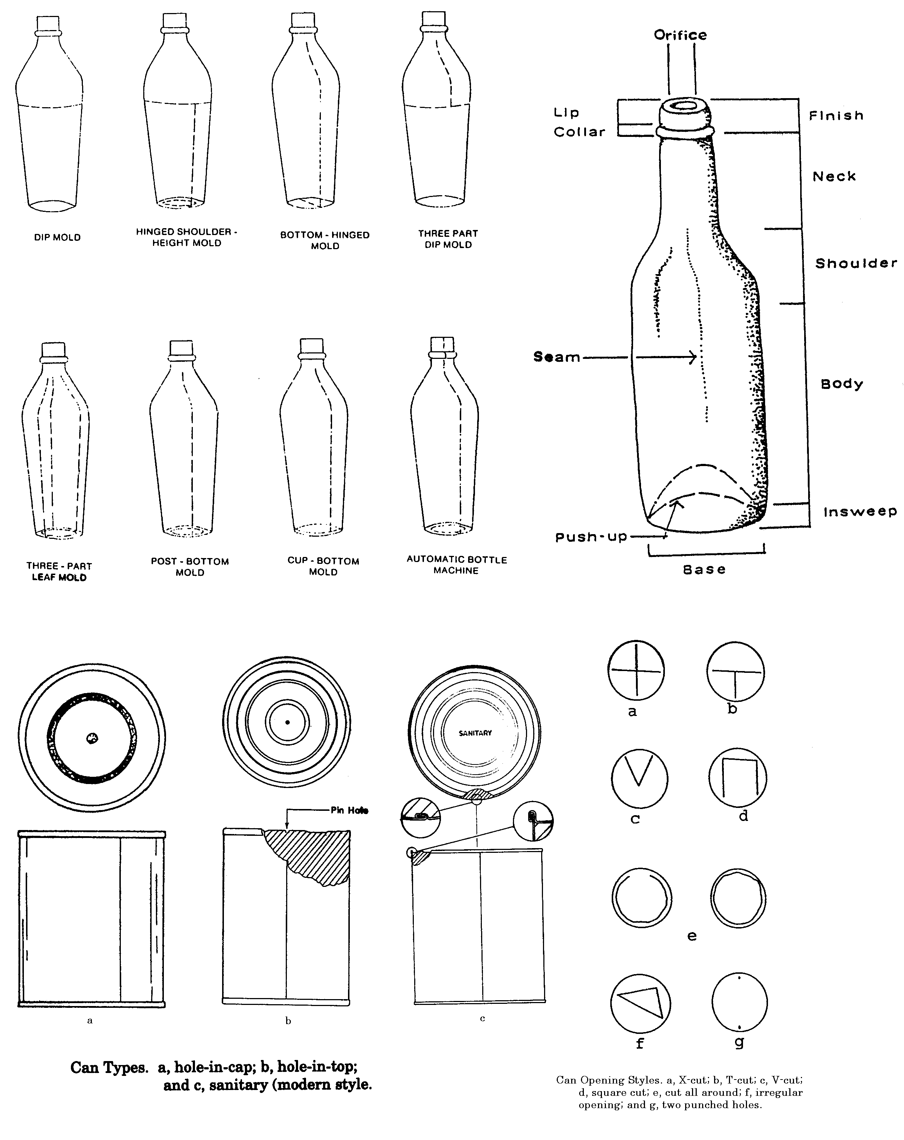

Bottle seams indicative of mold type, bottle nomenclature, can types, and can opening styles.
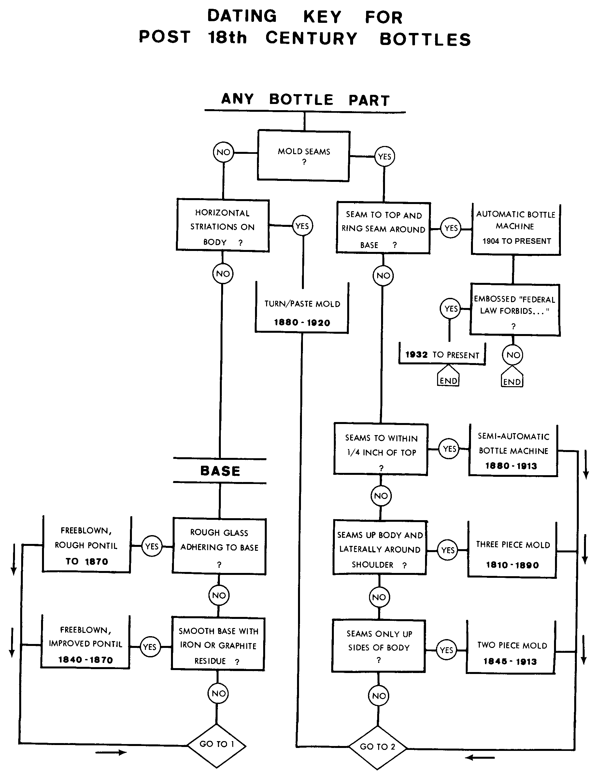

Dating key for bottles from D. Stell Newman, 1970, A Dating Key for Post-Eighteenth Century Bottles. Historical Archaeology 4:72-75.
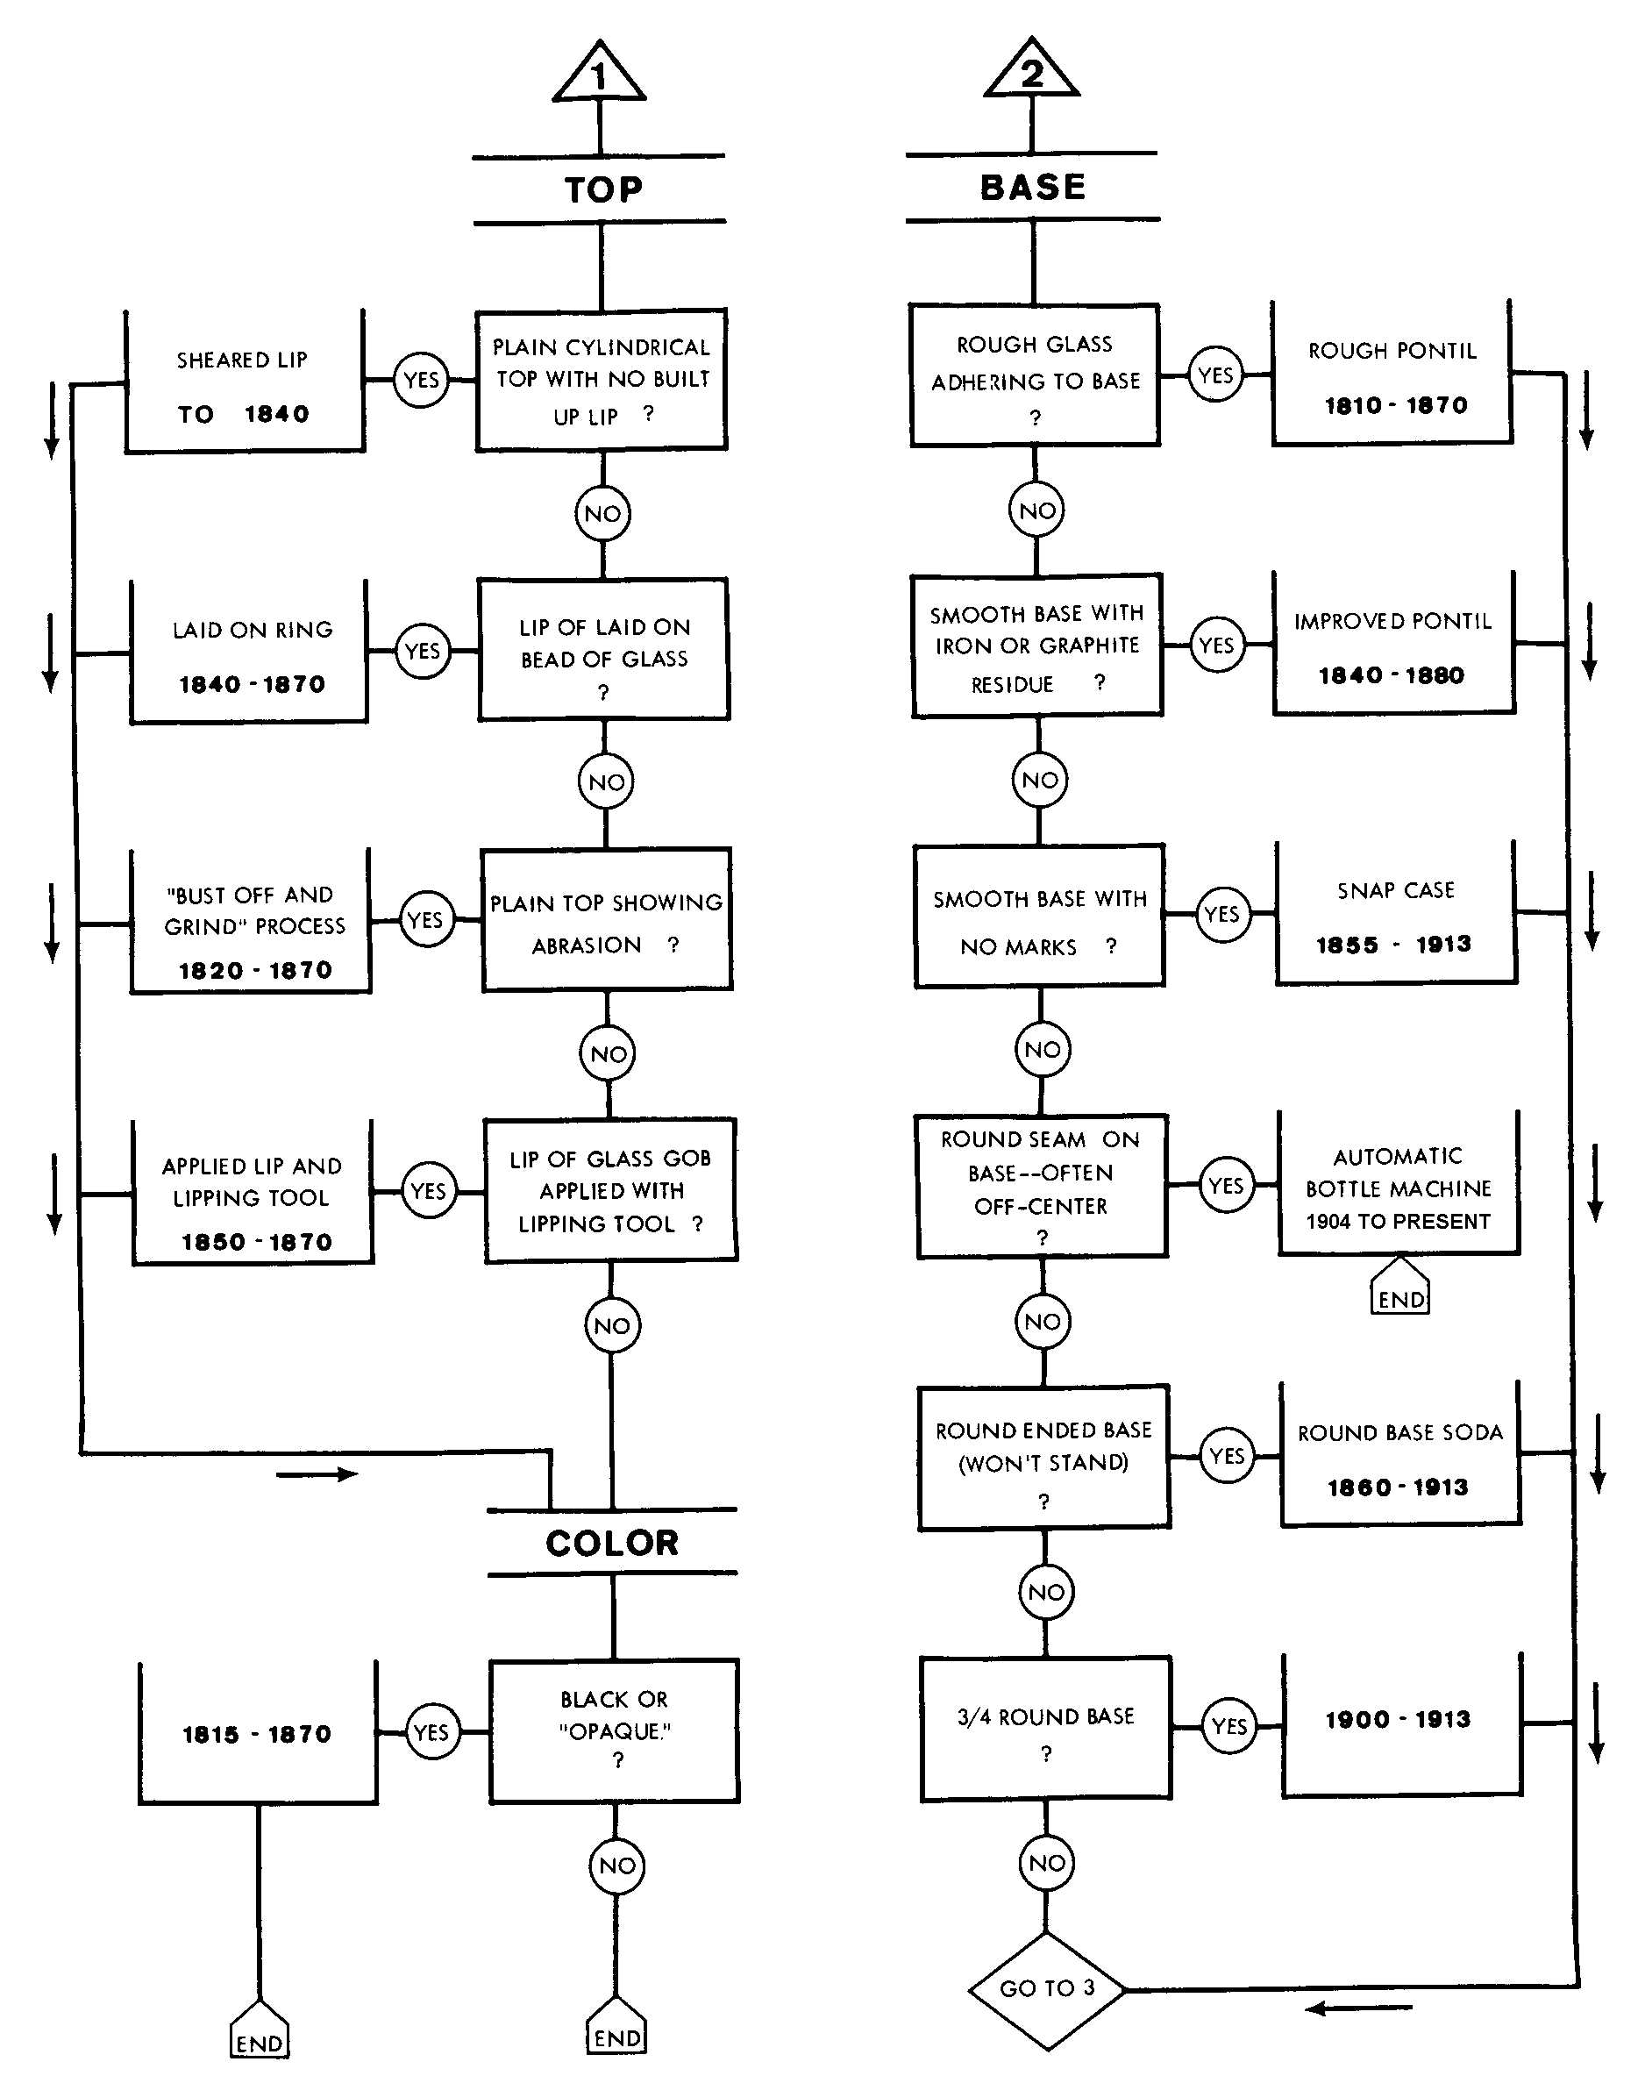
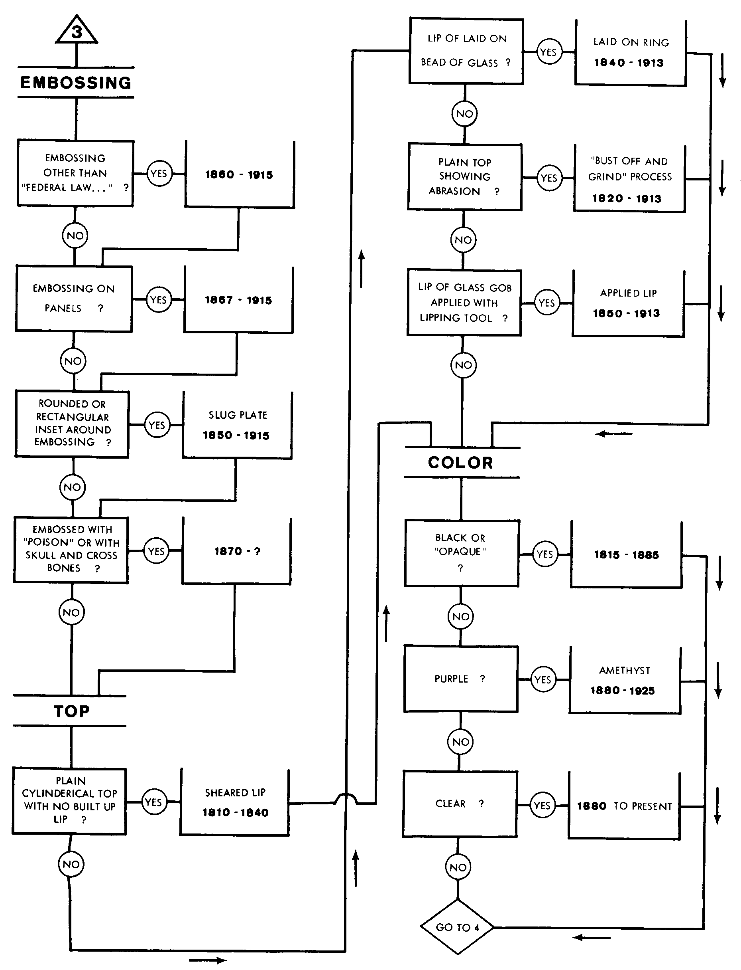
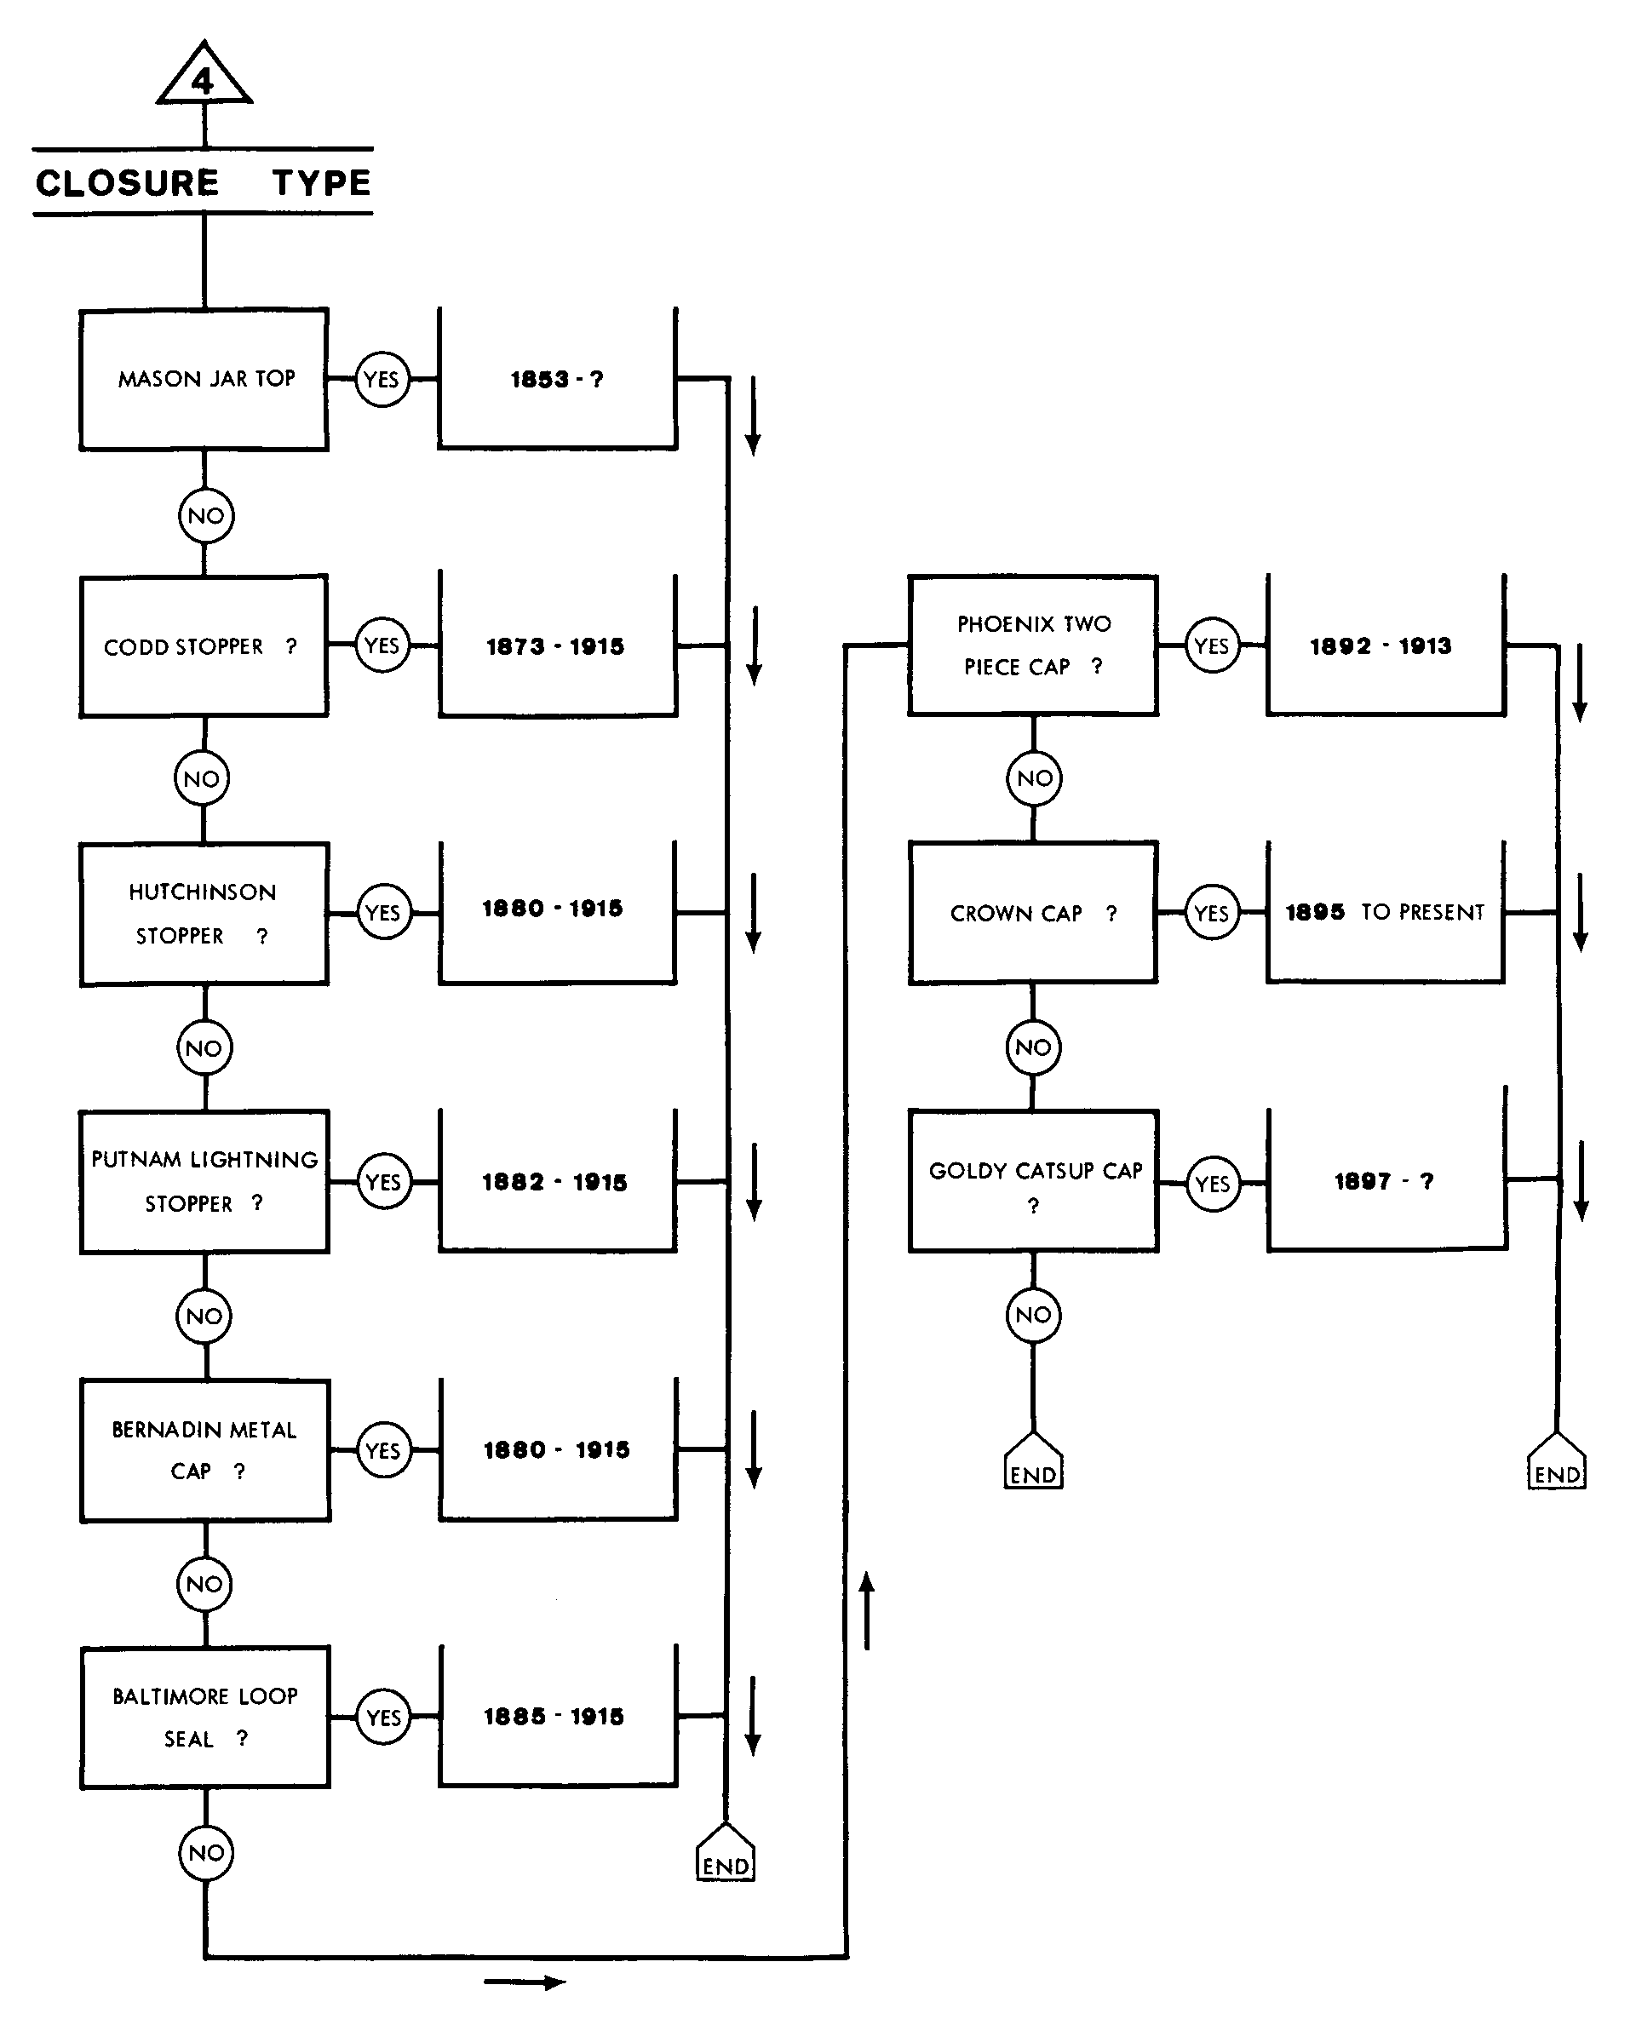

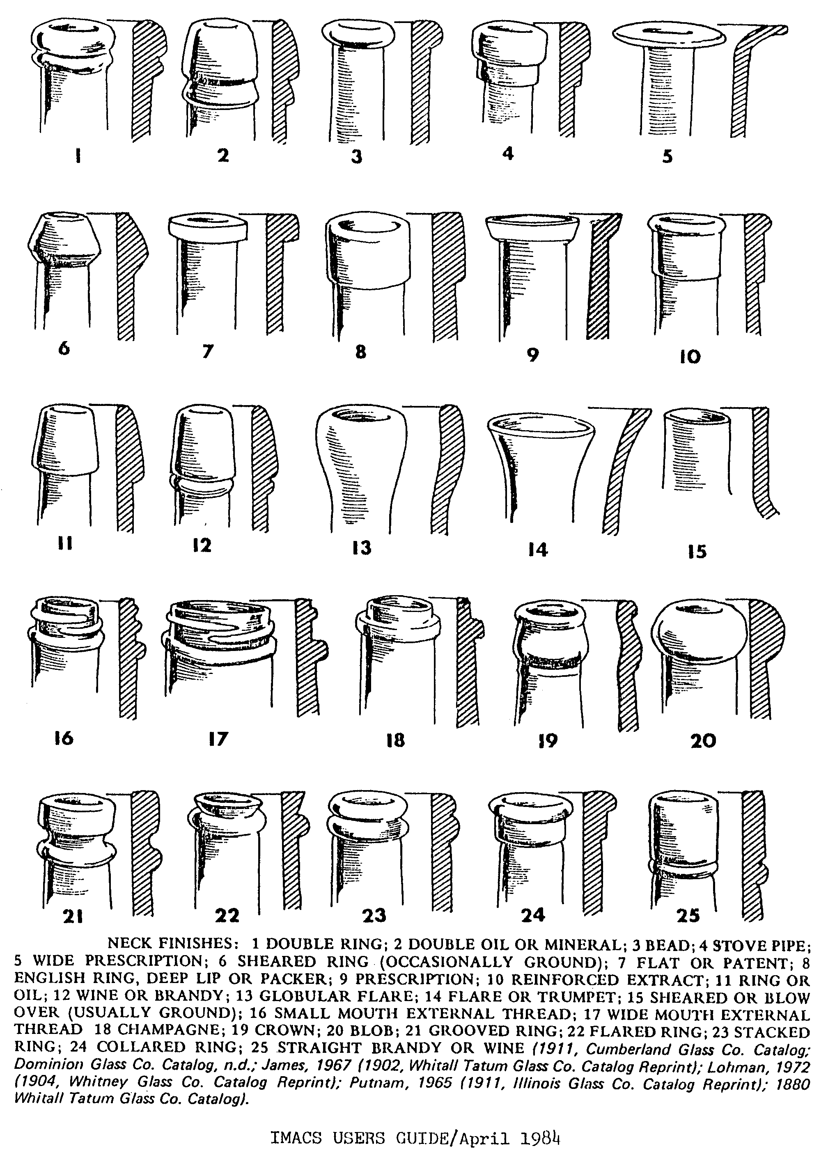

Bottle neck finishes from: Fike, Richard E.
1987 The Bottle Book: A Comprehensive Guide to Historic, Embossed Medicine Bottles. Peregrine Smith Books, Salt Lake City.
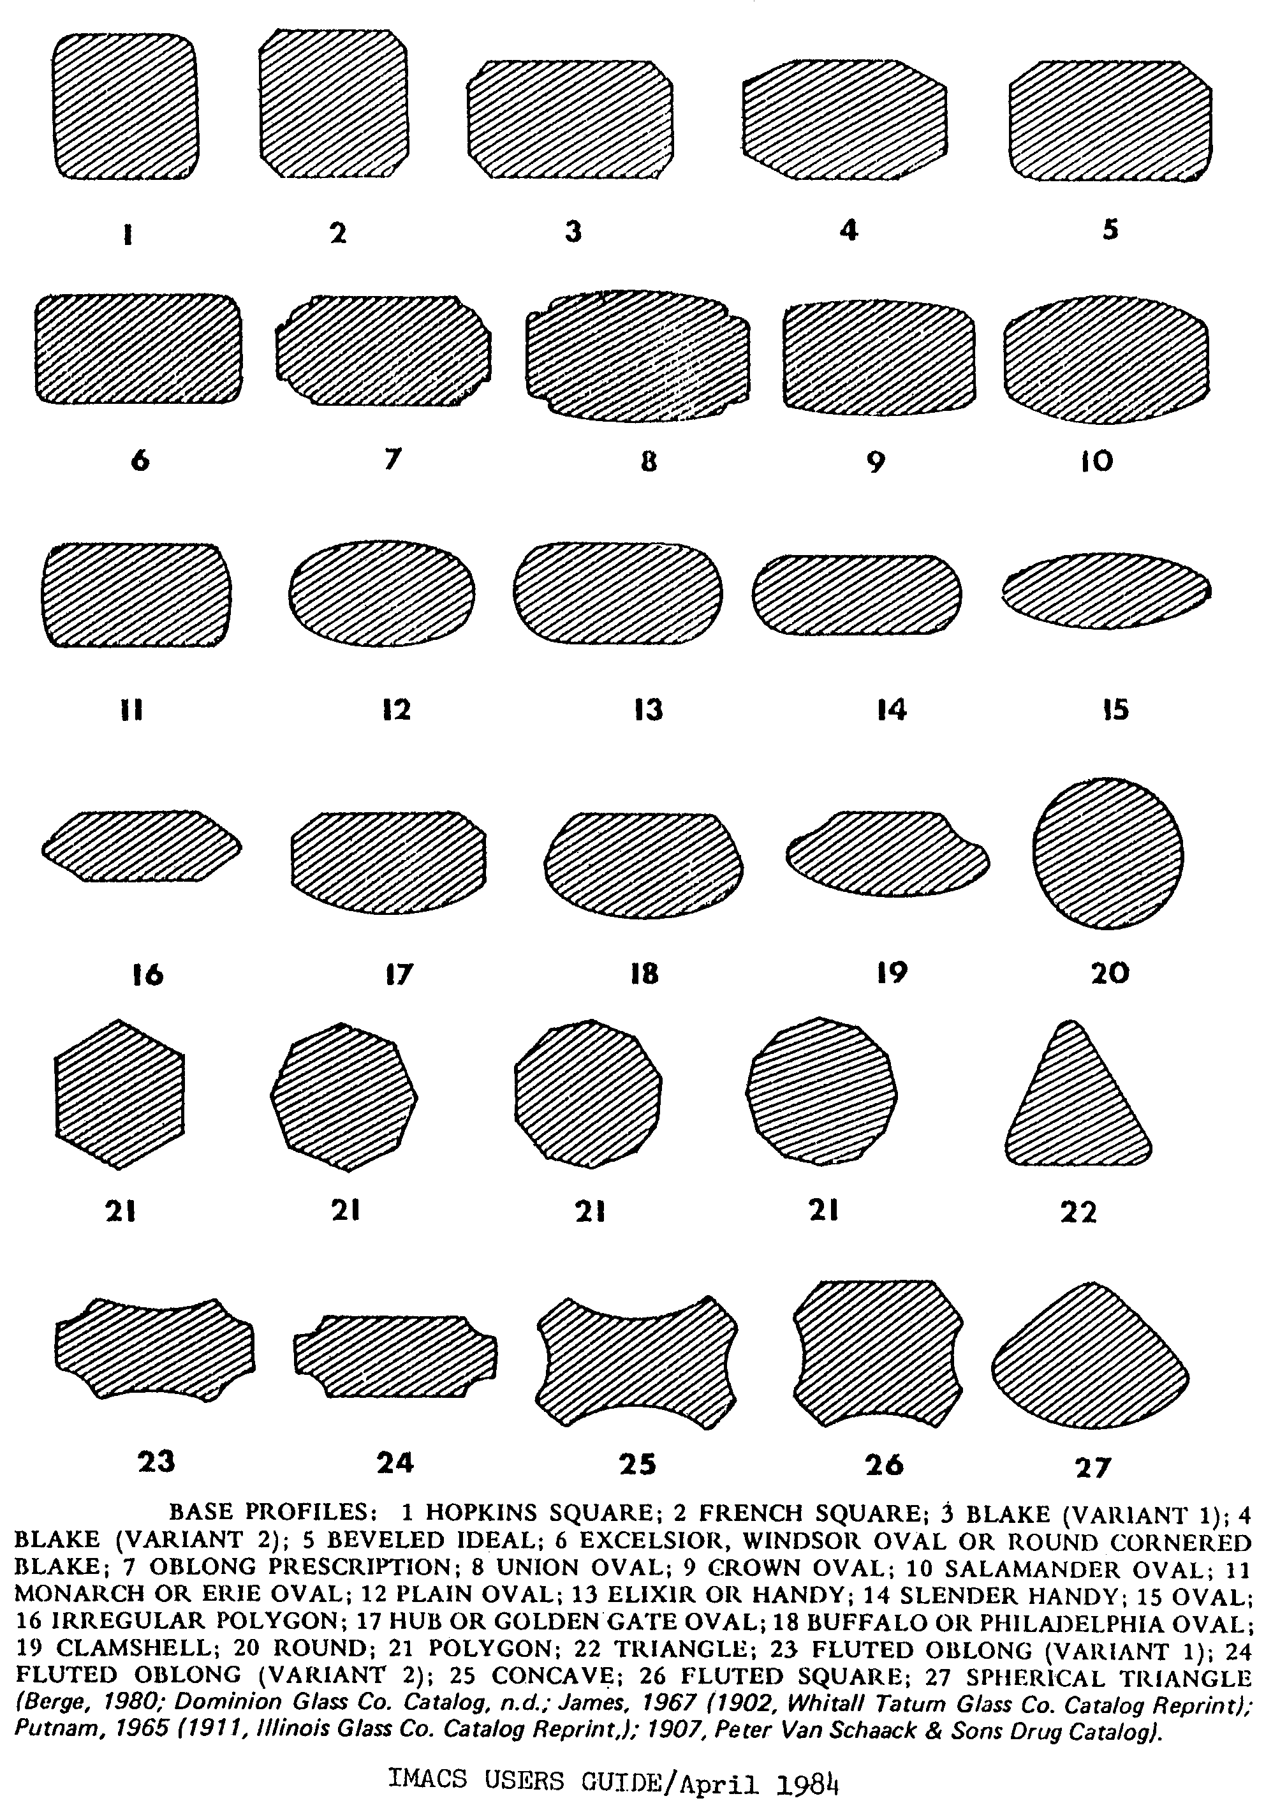

Bottle base shapes from: Fike, Richard E.
1987 The Bottle Book: A Comprehensive Guide to Historic, Embossed Medicine Bottles. Peregrine Smith Books, Salt Lake City.

CHRONOLOGY OF STYLISTIC DEVELOPMENT OF THE BEER CAN
Date Feature Introduced
1980s -UPC computer codes standard feature on all cans.
-Multiple neck-in chimes present on cans produced in the early years of the decade.
-Single, longer neck-in chimes prevalent during latter years of the decade.
1989 -Government alcohol warning labels introduced.
1984 -Straight-sided steel cans cease production.
1983 -Production of ring-pull cans ceases.
1970s -Production of II-oz., 15-oz., and gallon cans ceases.
-UPC computer codes introduced.
1977 -Coors phases out push-button cans.
1975 -American Can Company begins producing push-button cans.
1974-1979 -Cans issued commemorating the U.S. bicentennial.
1972 -Oregon bans the use of ring-pull cans. Push-button can openings introduced by Coors.
-Cans with specialized shapes first marketed.
1967 -Tin-free steel (TFS) cans introduced.
1966 -Welded-seam cans introduced.
-"Neck-in chime" cans (lid smaller than can body) introduced.
1965 -First "ring-pull" can marketed.
1964 -Continental Can's "U-tab" design introduced.
-Tab-tops with "smile" beads introduced.
-Gallon cans introduced.
1963 -In January, Schlitz becomes first national brewer to use tab-top cans. By August, 65 brands are available in this design.
-First 12-oz. all-aluminum can issued.
-Plastic six-pack holder (yoke) introduced.
1962 -First self-opening can ("snap-top" or "tab-top") introduced by Pittsburgh Brewing Company.
1960 -Cones completely phased out by this time.
1950s -Crowntainers phased out by mid-decade. -Cones largely phased out by mid-decade.
-Odd-size cans marketed include 7-, 8-, 10-, II-, 14-, and 15-oz. sizes.
-Aluminum lids used on steel-bodied cans. These are often described on can labels as "soft- tops."
-Pastels and metallic colors become common features of can labels.
1959 -Coors markets 7-oz. all-aluminum can.
1958 -Primo markets II-oz. paper-labeled, all-aluminum can.
1954 -Schlitz markets the first l6-oz. punch-top can.
1950 -"Internal Revenue Tax Paid" marking removed from can (and bottle) labels, March 30.
1942-1947 -Domestic canned beer production ceased due to World War II. Over 18 million cans of beer produced for military use.
-Military beer cans are silver or olive drab in color.
-Military cans are not marked "Internal Revenue Tax Paid" but, rather, "Withdrawn Free of Tax for Exportation."
1940 -J-spout cans phased out of production.
-Introduction of crowntainer, which replaces the J spout.
1930s -Most cans feature heavy paint and lacquer, resulting in good label preservation.
-The word "beer" is usually as prominent as the brand name, owing to the novelty of having beer in cans.
-Opening instructions, usually with illustrations, are included as part of the label (usually near the seam).
-Contents are often described as "contains 12 fluid ounces-same as a bottle."
1937 -Cones produced after this date have concave bottoms and long cones ("high-profile").
-J-spout cans introduced.
-Quart-size cones introduced in July.
1935 -First can marketed on January 24 in Richmond, Virginia. Eighteen breweries are canning beer by end of year.
-Beginning June 28, all cans produced are marked "Internal Revenue Tax Paid."
-Cone-top cans first marketed in September. These have flat bottoms and short cones ("low- profile").
Note. It is often difficult (if not impossible) to document the dates when various features are eliminated or removed from use, due primarily to the fact that old stock is frequently utilized after changes have been made. The presence of multiple suppliers (and in some cases, brewery locations) will also result in the simultaneous usage of different styles of cans (i.e., a single brewing company may produce aluminum and crimped-steel cans in different plants).

From: Maxwell, D. B. S.
1993 Beer Cans: A Guide for the Archaeologist. Historical Archaeology 27(1):95-113.

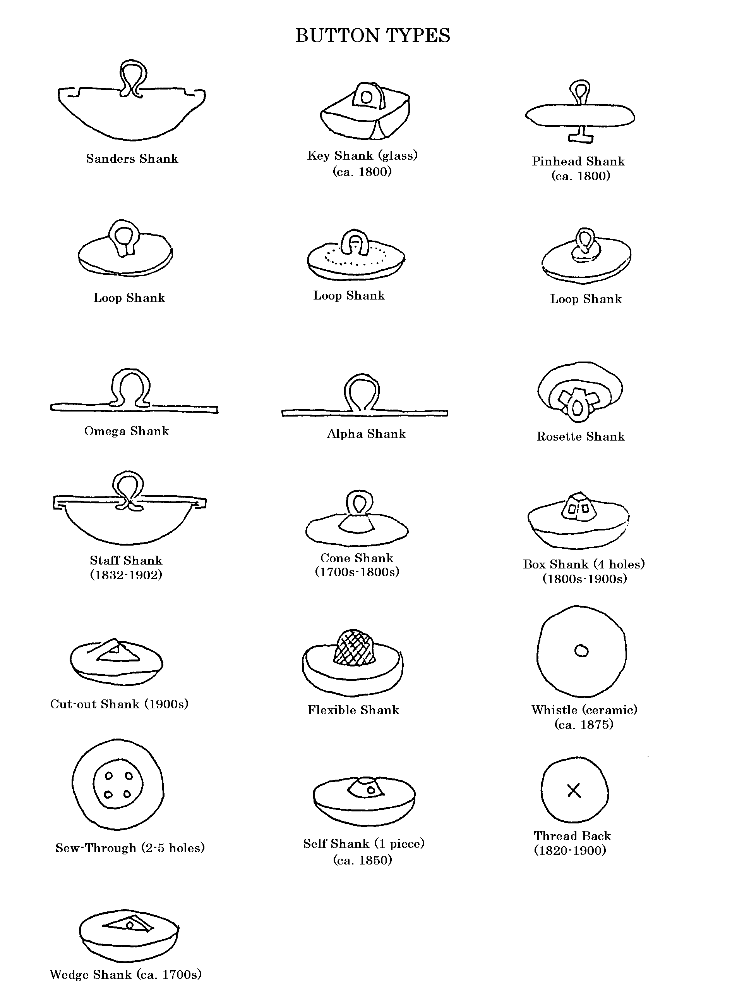

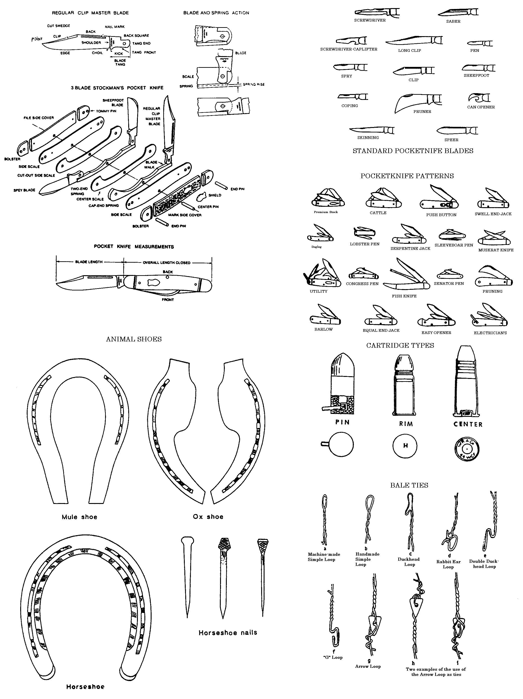
Pocketknives, animal shoes, cartridge types, and bale ties.
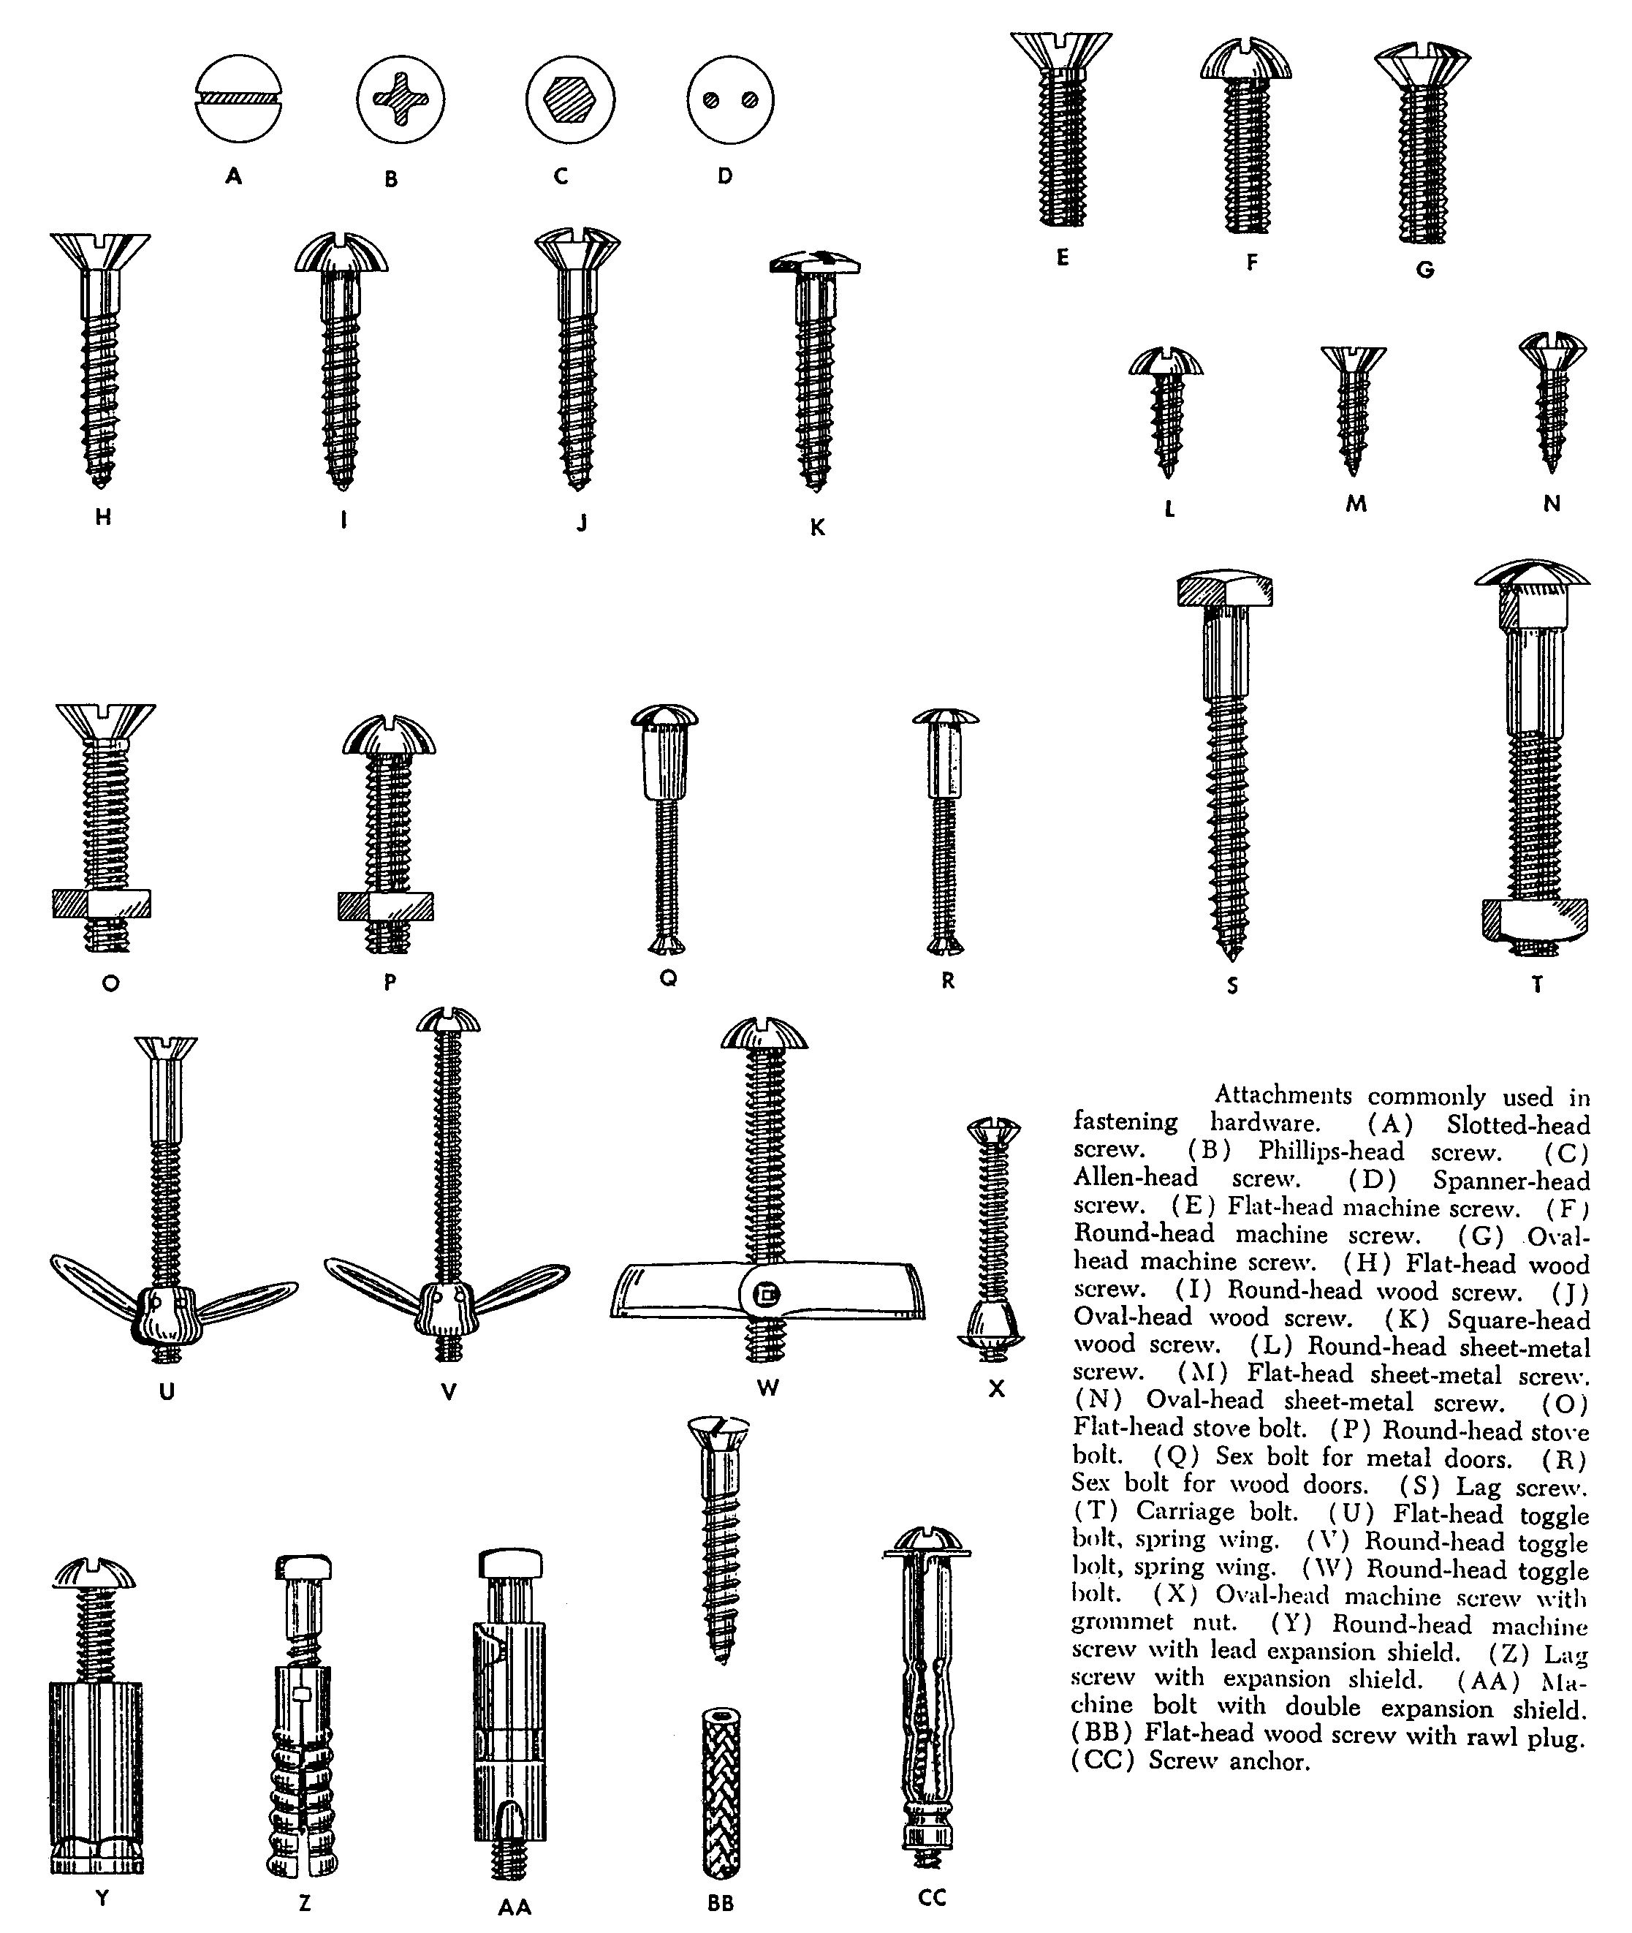

Screw nomenclature from: Brownell, Adon H.
n.d. Hardware Age Builders' Hardware Handbook. Chilton Company - Book Division, Publishers, Philadelphia.
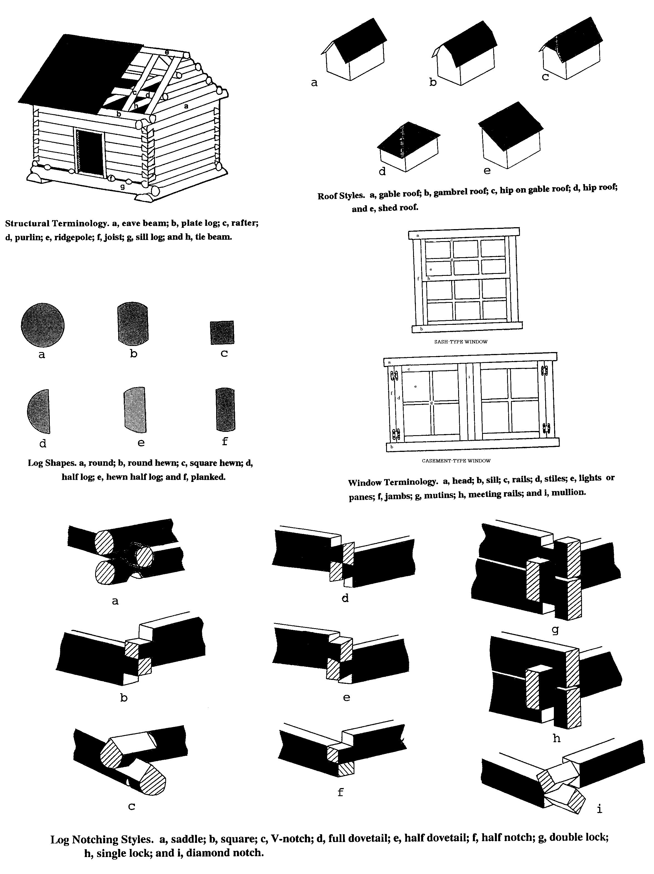
Cabin and architectural information adapted from: Wilson, Mary
1984 Log Cabin Studies, the Rocky Mountain Cabin, Log Cabin Technology and Typology and Log Cabin Bibliography. U.S. Forest Service, Intermountain Region, Cultural Resource Report No. 9.
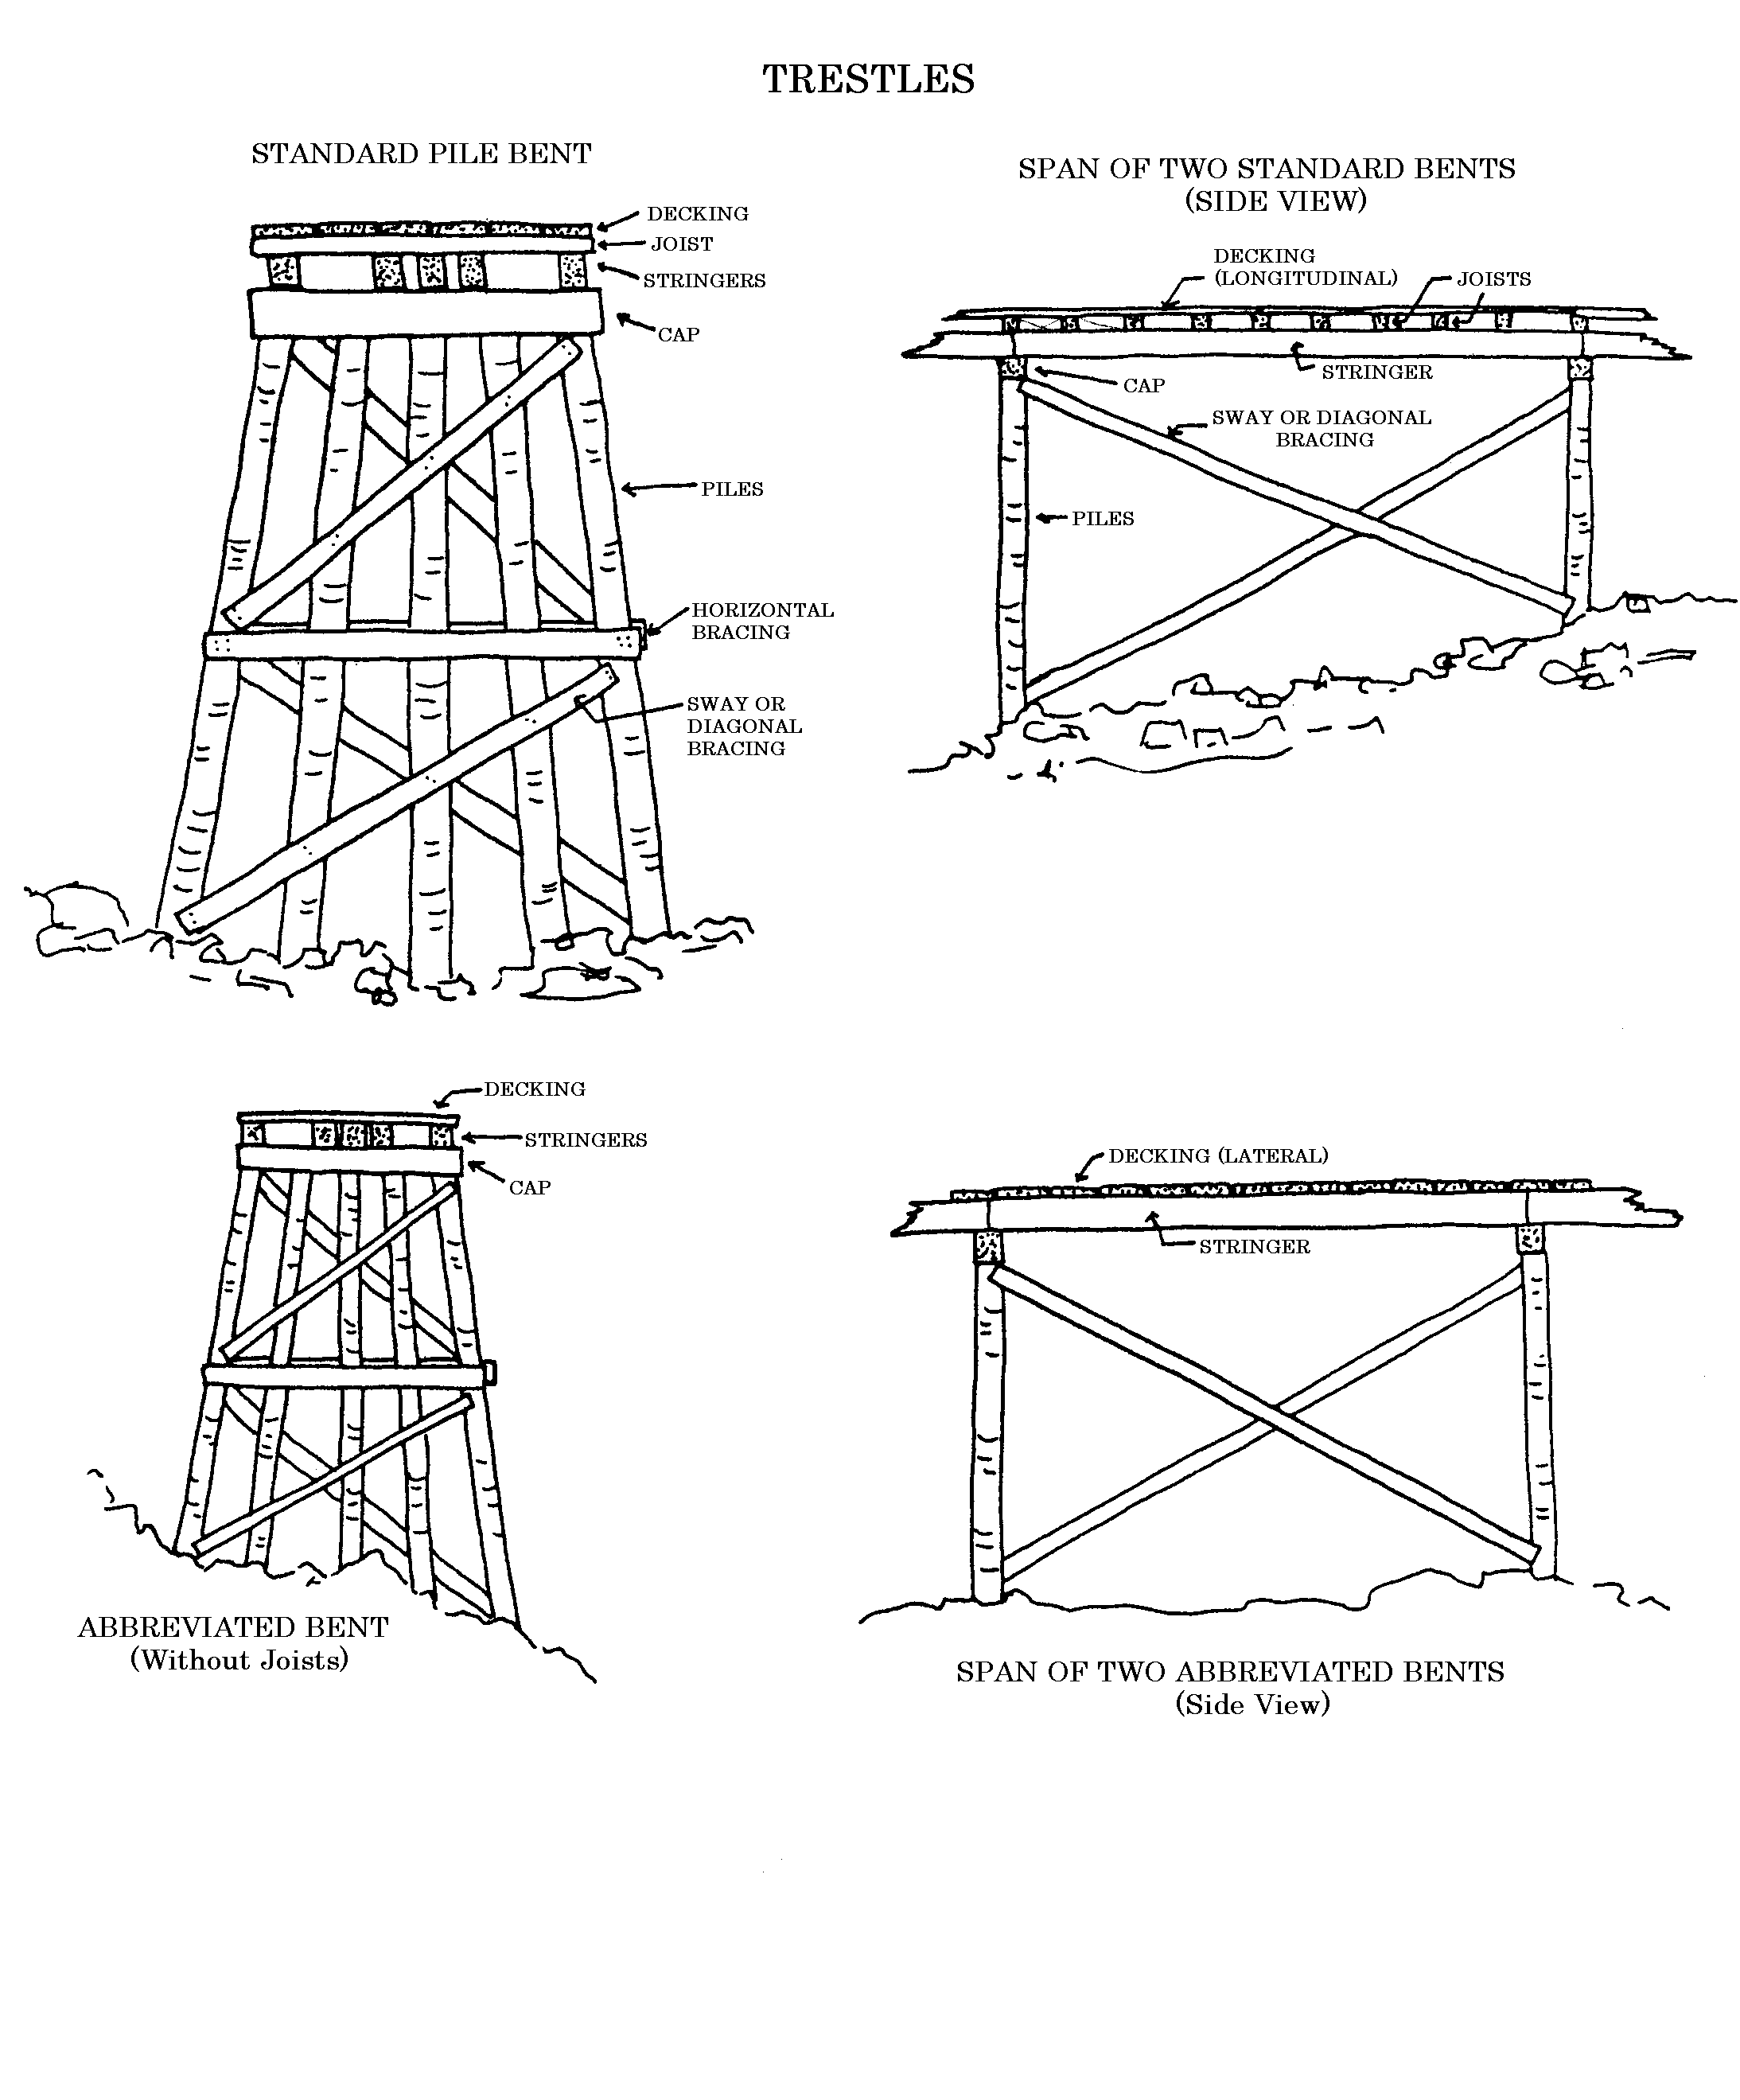

ARTIFACT IDENTIFICATION BIBLIOGRAPHY

General Classification and Company Histories

Adams, William Hampton
2003 Dating Historical Sites: The Importance of Understanding Time Lag in the Acquisition, Curation, Use, and Disposal of Artifacts. Historical Archaeology 37(2):38-64.

Blackaby, James R., and Patricia Greeno
1988 The Revised Nomenclature for Museum Cataloging: A Revised and Expanded Version of Robert G. Chenhall's System for Classifying Man-Made Objects. American Association for State and Local History, Nashville.

Brand Names Foundation, Incorporated
1947 43,000 Years of Public Service: A Roster of Product-identifying Names Used by the American Public for 50 Consecutive Years or More. Brand Names Foundation, Incorporated, New York.

Chenhall, Robert G.
1978 Nomenclature for Museum Cataloging: A System for Classifying Man-made Objects. American Association for State and Local History, Nashville.

Clark, Victor S.
1929 History of Manufactures in the United States. Volume II: 1860-1893. Carnegie Institution of Washington, Washington, D.C. Reprinted 1949 by Peter Smith, New York.

1929 History of Manufactures in the United States. Volume III: 1893-1928. Carnegie Institution of Washington, Washington, D.C. Reprinted 1949 by Peter Smith, New York.

Cramp, Arthur J.
1912 Nostrums and Quackery. American Medical Association Press, Chicago.

1921 Nostrums and Quackery, Vol. II. Press of American Medical Association, Chicago.

1936 Nostrums and Quackery and Pseudo-Medicine, Vol. III. Press of American Medical Association, Chicago.

Fisher, David, and Reginald Bragonier, Jr.
1981 What's What: A Visual Glossary of the Physical World. Hammond Incorporated, Maplewood, NJ.

Hambleton, Ronald
1987 The Branding of America: From Levi Strauss to Chrysler, from Westinghouse to Gillette, the Forgotten Founders of America's Best-Known Brand Names. Yankee Books, Camden, Maine.

Kelley, Etna M.
1954 The Business Founding Date Directory. Morgan & Morgan Publishers, Scarsdale, New York.

Panati, Charles
1987 Extraordinary Origins of Everyday Things. Harper & Row, Publishers, New York.

Periodical Publishers Association
1934 Nationally Established Trade-Marks. Periodical Publishers Association, New York.

Riley, John J.
1958 A History of the American Soft Drink Industry: Bottled Carbonated Beverages, 1807-1957. American Bottlers of Carbonated Beverages, Washington, D.C. Reprinted 1972 by Arno Press, New York.

Multiple Artifacts

Adams, William H.
1977 Silcott, Washington: Ethnoarchaeology of a Rural American Community. Reports of Investigations, No. 54. Laboratory of Anthropology, Washington State University, Pullman.

Adams, William H., Linda P. Gaw, and Frank C. Leonhardy
1975 Archaeological Excavations at Silcott, Washington: the Data Inventory. Reports of Investigations, No. 53. Laboratory of Anthropology, Washington State University, Pullman.

Berge, Dale L.
1980 Simpson Springs Station: Historical Archaeology in Western Utah, 1974-1975. Bureau of Land Management, Utah, Cultural Resource Series No. 6.

Gillio, David, Francis Levine, and Douglas Scott
1980 Some Common Artifacts Found at Historical Sites. Cultural Resources Report No. 31. U.S.DA Forest Service, Southwest Region, Albuquerque, New Mexico.

Herskovitz, Robert M.
1978 Fort Bowie Material Culture. Anthropological Papers of the University of Arizona No. 31. Tucson.

Kovel, Ralph M., and Terry H. Kovel
1986 Kovel’s New Dictionary of Marks. Crown Publishers, New York.

Lichty, Alan S., and Joel D. McNamara
1984 IMACS Users Guide. Intermountain Antiquities Computer System, revised edition.

Montgomery Ward & Company
1895 Montgomery Ward & Co. Catalogue and Buyers' Guide No. 57, Spring and Summer 1895. Reprint 1969 by Dover Publications, New York.

1894-5 Montgomery Ward & Co. 1894-95 Catalogue & Buyers Guide No. 56. Reprint 1977 by DBI Books, Inc., Northfield, Illinois.

Noël Hume, Ivor
1970 A Guide to Artifacts of Colonial America. Alfred A. Knopf, New York.

Petsche, Jerome E.
1974 The Steamboat Bertrand: History, Excavation, and Architecture. National Park Service Publications in Archeology 11. GPO, Washington.

Russell, Carl P.
1967 Firearms, Traps & Tools of the Mountain Men. Alfred A. Knopf, New York.

Sagstetter, Beth, and Bill Sagstetter
1998 The Mining Camps Speak: A New Way to Explore the Ghost Towns of the American West. Benchmark Publishing of Colorado, Denver.

Sears, Roebuck and Co.
1894 Sears, Roebuck and Co. Consumer's Guide for 1894. Reprint edition.

1902 The 1902 Edition of the Sears, Roebuck Catalog, No. 111. Reprinted 1969 by Bounty Books, New York.

1908 Sears, Roebuck and Company 1908 Catalogue, No. 117, The Great Price Maker. Reprinted by Gun Digest Co., Chicago.

1909 Sears, Roebuck and Co., Incorporated Consumers Guide, Fall 1909, No. 118. Reprinted by Ventura Books, Inc., New York, 1979.

1915 Tools, Machinery, Blacksmiths' Supplies. Sears, Roebuck and Co., Chicago. Reprinted 1985 by the Mid-West Tool Collectors Association and the Artist Blacksmith's Association of North America, n.p.

Richardson, M. T.
1998 Practical Blacksmithing. 2 Vols. Astragal Press, Mendham, New Jersey.

Agriculture

Baird, James S.
1994 Hoard’s Dairyman Dairy Collectibles: A Pictorial Guide to Collecting and Identifying Items Related to Dairying. W. D. Hoard & Sons Company, Atkinson, Wisconsin.

Hurt, R. Douglas
1982 American Farm Tools from Hand-Power to Steam-Power. Sunflower University Press, Manhattan, Kansas.

Montgomery Ward & Company
1908 Farm Implements. Montgomery Ward & Co., Chicago.

Rathbone, Pembroke Thom
1999 The History of Old Time Farm Implement Companies and the Wrenches They Issued Including Buggy, Silo, Cream Separator, Windmill and Gas Engine Companies. Pembroke Thom Rathbone, Marsing, Idaho.

1999 The History of Old Time Farm Implement Companies and the Wrenches They Issued Including Buggy, Silo, Cream Separator, Windmill and Gas Engine Companies Supplement. Pembroke Thom Rathbone, Marsing, Idaho.

Wendel, C. H.
1997 Encyclopedia of American Farm Implements & Antiques. Krause Publications, Iola, Wisconsin.

Arms and Ammunition

Barnes, Frank C.
1993 Cartridges of the World. DBI Books, Inc., Northbrook, IL.

Bearse, Ray
1966 Centerfire American Rifle Cartridges 1892-1963. A. S. Barnes and Co., Inc., South Brunswick, New Jersey.

Brinckerhoff, Sidney B. and P. A. Chamberlain
1972 Spanish Military Weapons in Colonial America: 1700-1821. Stackpole Books, Harrisburg, Pennsylvania.

Datig, Fred A.
1956 Cartridges for Collectors, Vol. I (Centerfire). FADCO Publishing Co., Beverly Hills, California.

1958 Cartridges for Collectors, Vol. II. FADCO Publishing Co., Beverly Hills, California.

Kass, George G., editor
1979 Rimfire Headstamp Guide: Part I. George G. Kass, Okemos, Michigan.

Logan, Herschel C.
1959 Cartridges: A Pictorial Digest of Small Arms Ammunition. Bonanza Books, New York.

Murtz, Harold A., editor
1993 The Gun Digest Book of Exploded Long Gun Drawings. DBI Books, Inc., Northbrook, Illinois.

Russell, Carl P.
1957 Guns on the Early Frontiers: A History of Firearms from Colonial Times through the Years of the Western Fur Trade. University of Nebraska Press, Lincoln.

Barbed Wire

Clifton, Robert T.
1970 Barbs, Prongs, Points, Prickers & Stickers: A Complete and Illustrated Catalogue of Antique Barbed Wire. University of Oklahoma Press, Norman.

Glover, Jack
1969 The "Bobbed" Wire Bible. Jack Glover, Sunset, Texas.

Bottles

Baldwin, Joseph K.
1973 A Collector's Guide to Patent and Proprietary Medicine Bottles of the Nineteenth Century. Thomas Nelson, Inc., New York.

Clint, David K.
1976 Colorado Historical Bottles & ETC., 1859-1915. Johnson Publishing Company, Boulder, Colorado.

Clorox Company, The
1999 The Clorox Bottle Guide: An Aid for Collectors. The Clorox Company (http://www.clorox.com/company/bottlguide/). January 6, 2000.

Coors, Adolph, Company
1984 Time in a Bottle. Adolph Coors Company, Golden, Colorado.

Devner, Kay
1968 Patent Medicine Picture. The Tombstone Epitaph, Tombstone, Arizona.

Fike, Richard E.
1987 The Bottle Book: A Comprehensive Guide to Historic, Embossed Medicine Bottles. Peregrine Smith Books, Salt Lake City.

Fountain, John C., and Donald E. Colcleaser
1968 Dictionary of Soda and Mineral Water Bottles. Ole Empty Bottle House Publishing Co., Amador City, California.

1969 Dictionary of Spirits and Whiskey Bottles. Ole Empty Bottle House Publishing Company, Amador City, California.

Howe, John
1967 A Whiskeyana Guide: Antique Whiskey Bottles. John Howe, San Jose, California.

James, D.
1967 Whitall, Tatum and Company, Drug, Perfume and Chemical Bottles, 1902. Reprint of historic catalog, n.p.

Jones, Olive

1971 Glass Bottle Push-Ups and Pontil Marks. Historical Archaeology 5:62-73.

Kovel, Ralph M., and Terry H. Kovel
1971 The Official Bottle Price List. Crown Publishers, Inc., New York.

Lief, Alfred
1965 A Close-Up of Closures: History and Progress. Glass Manufacturers Institute, New York.

Lockhart, Bill
2004 The Dating Game. Bottles and Extras 15(3):2-5.

2006 Owens-Illinois Glass Company. SHA Newsletter 39(2):22-27.

Lorrain, Dessamae
1968 An Archaeologist’s Guide to Nineteenth Century American Glass. Historical Archaeology 2:35-44.

Miller, George L., and Catherine Sullivan
1984 Machine-Made Glass Containers and the End of Production for Mouth-Blown Bottles. Historical Archaeology 18(2):83-96.

Peterson, Arthur G.
1968 400 Trademarks on Glass. Washington College Press, Takoma Park, Maryland.

Rock, Jim
1981 Glass Bottles: Basic Identification. U.S.DA, Klamath National Forest, Yreka, California.

Schulz, Peter D., Betty J. Rivers, Mark M. Hales, Charles A. Litzinger, and Elizabeth A. McKee
1980 The Bottles of Old Sacramento: A Study of Nineteenth Century Glass and Ceramic Retail Containers, Part I. California Archeological Reports No. 20. State of California, Department of Parks and Recreation, Sacramento.

Seamans, Berna Mackey, and Mertie Mackey Robb
1969 Colorado Bottle History: When and Where? R & S Publication, Denver.

Switzer, Ronald R.
1974 The Bertrand Bottles: A Study of 19th-Century Glass and Ceramic Containers. National Park Service Publications in Archeology No. 12. GPO, Washington.

Toulouse, Julian Harrison
1971 Bottle Makers and Their Marks. Thomas Nelson Inc., New York.

1977 Fruit Jars: A Collector's Manual with Prices. Thomas Nelson Inc., Publishers, Nashville, Tennessee.

Watson, Richard
1965 Bitters Bottles. Thomas Nelson and Sons, New York.

White, James Seeley
1974 The Hedden's Store Handbook of Proprietary Medicines. Durham & Downey, Portland, Oregon.

Wilson, Bill, and Betty Wilson
1968 Spirits Bottles of the Old West. Henington Publishing Company, Wolfe City, TX.

Wilson, Rex L.
1981 Bottles on the Western Frontier. The University of Arizona Press, Tucson.

Zumwalt, Betty
1980 Ketchup, Pickles, Sauces: 19th Century Food in Glass. Mark West Publishers, Fulton, California.

Buttons

Adams, Jane Ford, and Lillian Smith Albert
1965 A Descriptive Catalog of Pictorial Buttons Worn on Work Clothing 1900-1935. Sullivan Lithographics, Wichita, Kansas.

Brown, Dorothy Foster
1968 The New Enlarged and Revised Button Parade. Mid-America Book Company, Leon, Iowa.

Century House
1959 Military Uniforms and Their Buttons. Century House, Watkins Glen, New York.

Houart, Victor
1977 Buttons: A Collector's Guide. Charles Scribner's Sons, New York.

Johnson, David F.
1948 Uniform Buttons: American Armed Forces 1784-1948, Vol. I: Descriptions & Value. Century House, Watkins Glen, New York.

1959 Uniform Buttons: American Armed Forces 1784-1948, Vol. II. Century House, Watkins Glen, New York.

Quartermaster General, U.S. Army
1889 U.S. Army Uniforms and Equipment, 1889 Specifications for Clothing, Camp and Garrison Equipage, and Clothing and Equipage Materials. Reprinted 1986, University of Nebraska Press, Lincoln.

Sprague, Roderick
2002 China or Prosser Button Identification and Dating. Historical Archaeology 36(2):111-127.

Cans

Beer Can Collectors of America
1975 The Beer Can Collectors of America Guide to United States Beer Cans. Greatlakes Living Press, Matteson, Illinois.

Maxwell, D. B. S.
1993 Beer Cans: A Guide for the Archaeologist. Historical Archaeology 27(1):95-113.

May, Earl Chapin
1937 The Canning Clan: A Pageant of Pioneering Americans. The Macmillan Company, New York.

Rock, Jim
1981 Tin Cans, Notes and Comments. U.S.DA, Klamath National Forest, Yreka, California.

1984 Cans in the Countryside. Historical Archaeology 18(2)97-111.

Ceramics

Barber, Edwin Atlee
1904 Marks of American Potters. Patterson & White Company, Philadelphia.

Butler Brothers
1930 China & Glassware 1930. 1968 reprint of Butler Brothers Catalog #2749. Antique Research Publications, Chattanooga, Tennessee.

Chaffers, William
1946 Marks & Monograms on European and Oriental Pottery and Porcelain. Borden Publishing Company, London.

Cushion, J. P.
1961 Pocket Book of German Ceramic Marks and Those of Other Central European Countries. Faber and Faber, London.

Gates, William C., Jr., and Dana E. Ormerod
1984 The East Liverpool Pottery District: Identification of Manufacturers and Marks. Historical Archaeology 16(1-2).

Godden, Geoffrey A.
1991 Encyclopaedia of British Pottery and Porcelain Marks. Barrie & Jenkins, London.

Kovel, Ralph M., and Terry H. Kovel
1953 Dictionary of Marks, Pottery and Porcelain. Crown Publishers, Inc., New York.

Kowalsky, Arnold A., and Dorothy E. Kowalsky
1999 Encyclopedia of Marks on American, English, and European Earthenware, Ironstone, and Stoneware (1780-1980): Makers, Marks, and Patterns in Blue and White, Historic Blue, Flow Blue, Mulberry, Romantic Transferware, Tea Leaf, and White Ironstone. Schiffer Publishing Ltd., Atglen, Pennsylvania.

Lehner, Lois
1978 Ohio Pottery and Glass Marks and Manufacturers. Wallace Homestead Book Co., Des Moines, Iowa.

1980 Complete Book of American Kitchen and Dinner Ware. Wallace-Homestead Book Company, Des Moines, Iowa.

1988 Lehner’s Encyclopedia of U.S. Marks on Pottery, Porcelain & Clay. Collector Books, Paducah, Kentucky.

McKee, Floyd W.
1966 The Second Oldest Profession: A Century of American Dinnerware Manufacture. Privately published, n.p.

Ramsey, John
1939 American Potters and Pottery. Colonial Press Inc., Clinton, Massachusetts.

Thorn, C. Jordan
1947 Handbook of Old Pottery and Porcelain Marks. Tudor Publishing Company, New York.

Weatherbee, Jean
1980 A Look at White Ironstone. Wallace Homestead Book Company, Des Moine, Iowa.

Glassware

Florence, Gene
1986 Elegant Glassware of the Depression Era. Collector Books, Paducah, Kentucky.

1987 Kitchen Glassware of the Depression Years. Collector Books, Paducah, Kentucky.

1989 Pocket Guide to Depression Glass, Revised Sixth Edition. Collector Books, Paducah, Kentucky.

1998 Florence’s Glassware Pattern Identification Guide. Collector Books, Paducah, Kentucky.

2000 Florence’s Glassware Pattern Identification Guide, Volume II. Collector Books, Paducah, Kentucky.

Lee, Ruth Webb
1936 Ruth Webb Lee's Handbook of Early American Pressed Glass Patterns. Ruth Webb Lee, Publisher, Framingham Centre, Massachusetts.

Mauzy, Barbara and Jim Mauzy
2001 Mauzy’s Comprehensive Handbook of Depression Glass Prices, 3rd Edition. Schiffer Publishing Ltd., Atglen, Pennsylvania.

McKearin, George S., and Helen McKearin
1941 American Glass. Crown Publishers, New York.

Revi, Albert Christian
1964 American Pressed Glass and Figure Bottles. Thomas Nelson Inc., New York.

Hardware

Adams, William Hampton
2002 Machine Cut Nails and Wire Nails: American Production and Use for Dating 19th-Century and Early-20th-Century Sites. Historical Archaeology 36(4):66-88.

Barnes, Frank T.
1988 Hooks, Rings & Other Things: An Illustrated Index of New England Iron, 1660-1860. The Christopher Publishing House, Hanover, Massachusetts.

D'Allemagne, Henry Rene
1968 Decorative Antique Ironwork: A Pictorial Treasury. Dover Publications, Inc., New ork.

Eastwood, Maudie
1976 The Antique Doorknob. Times Litho, Forest Grove, Oregon.

Forney, Matthias N.
1974 The Railroad Car Builder’s Pictorial Dictionary. Dover Publications, Inc., New York.

Russell and Erwin Manufacturing Company
1865 Illustrated Catalogue of American Hardware of the Russell and Erwin Manufacturing Company. Reprinted 1980 by the Association for Preservation Technology, Lisle, Illinois.

Wells, Tom
1998 Nail Chronology: The Use of Technologically Derived Features. Historical Archaeology 32(2):78-99.

Horse Equipment and Harness

Ahlborn, Richard
1980 Man Made Mobil Early Saddles of Western North America. Smithsonian Institution Press, Washington.

Fitzgerald, William N.
1875 The Harness Makers' Illustrated Manual. Wm. N. Fitz-Gerald, NY. Reprinted 1974 by North River Press, Inc., Croton-on-Hudson, New York.

Fox, Charles Philip
1987 Horses in Harness: A Pictorial Recollection of the Horse-Drawn Decades. Reiman Associates, Greendale, Wisconsin.

Keegan, Terry
1973 The Heavy Horse: Its Harness and Harness Decoration. A.S. Barnes and Company, New York.

Lungwitz, A. and John W. Adams
1966 A Textbook of Horseshoeing for Horseshoers and Veterinarians. Oregon State University Press, Corvallis.

Moseman, C. M., and Brother
1987 Mosemans' Illustrated Catalog of Horse Furnishing Goods: An Unabridged Republication of the Fifth Edition. Dover Publications, Inc., New York.

Insulators

Hill, James L., and Edward Pickett
1968 An Insulator Book for Collectors, Sketches and Prices. The Mail Printers, Myrtle Creek, Oregon.

Kareofelas, Greg A., Gary G. Cranfill, and John C. Fountain
1969 A Catalogue and Reference to Insulators and Other Related Materials. Ole Empty Bottle House Publishing Company, Amador City, California.

Milholland, Marion C.
1971 Milhollands Complete Glass Insulator Reference Book. Sequim Press, Sequim, Washington.

Lamps and Lanterns

Bright, Arthur A., Jr.
1949 The Electric-Lamp Industry: Technological Change and Economic Development from 1800 to 1947. The Macmillan Company, New York.

Freeman, Larry
1944 Light on Old Lamps. Century House, Watkins Glen, New York.

Hobson, Anthony
1991 Lanterns That Lit Our World: How to Identify, Date, and Restore Old Railroad, Marine, Fire, Carriage, Farm, and Other Lanterns. Golden Hill Press, Inc., Spencertown, New York.

1996 Lanterns That Lit Our World, Book Two: Old Railroad, Marine, Fire, Carriage, Farm, & Other Lanterns. Golden Hill Press, Inc., Spencertown, New York.

Myers, Denys Peter
1978 Gaslighting in America: A Pictorial Survey, 1815-1910. Dover Publications, Inc., New York.

Pyne Press
1972 Lamps and Other Lighting Devices 1850-1906. Pyne Press, Princeton, New Jersey.

Wallace-Homestead Book Co.
1972 Lamps & Other Lighting Devices 1850-1906. Wallace-Homestead Book Co., Des Moines, Iowa.

Woodhead, E. I., C. Sullivan, and G. Gusset
1984 Lighting Devices in the National Reference Collection, Parks Canada. Studies in Archaeology, Architecture and History. National Historic Parks and Sites Branch, Parks Canada, Ottawa, Ontario.

Silver

Rainwater, Dorothy T.
1966 American Silver Manufacturers, Their Marks, Trademarks and History. Everybodys Press, Hanover, Pennsylvania.

Rainwater, Dorothy T. and Judy Redfield
1998 Encyclopedia of American Silver Manufacturers, Fourth Edition. Schiffer Publishing Ltd., Atglen, Pennsylvania.

Wyler, Seymour B.
1937 The Book of Old Silver, English - American - Foreign, With All Available Hallmarks Including Sheffield Plate Marks, Profusely Illustrated. Crown Publishers, New York.

Tools

Cope, Kenneth L.
1993 American Machinist’s Tools: An Illustrated Directory of Patents, Over 1000 Diagrams. Astragal Press, Mendham, New Jersey.

1994 More Makers of American Machinist’s Tools: A Historical Directory of Makers and Their Tools. Astragal Press, Mendham, New Jersey.

1998 More Makers of American Machinist’s Tools: A Historical Directory of Makers and Their Tools. Astragal Press, Mendham, New Jersey.

Kijowski, Gene W., editor
1990 Directory of American Tool Makers, Colonial Times to 1899, Working Draft Edition. Early American Industries Association, Albany, New York.

Pollak, Emil, and Martyl Pollak
1987 A Guide to American Wooden Planes and Their Makers. The Astragal Press, Morristown, New Jersey.

Salaman, R. A.
1975 Dictionary of Woodworking Tools and Tools of Allied Trades. Taunton Press, Inc., Newtown, Connecticut.

1986 Dictionary of Leather-working Tools, c.1700-1950 and the Tools of Allied Trades. Macmillan Publishing Company, New York.

Sellens, Alvin
1990 Dictionary of American Hand Tools: A Pictorial Synopsis. Alvin Sellens, Augusta, Kansas.

Smith, H. R. Bradley
1966 Blacksmith's and Farrier's Tools at Shelburne Museum: A History of their Development from Forge to Factory. Museum Pamphlet Series, Number 7. The Shelburne Museum, Inc., Shelburne, Vermont.

Toys

Baumann, Paul
1981 Collecting Antique Marbles. Wallace-Homestead Book Co., Des Moines, Iowa.

Best, Charles W.
1973 Cast Iron Toy Pistols 1870-1940: A Collector's Guide. Rocky Mountain Arms & Antiques, Englewood, Colorado.

Carskadden, Jeff, and Richard Gartley
1990 A Preliminary Seriation of 19th Century Decorated Porcelain Marbles. Historical Archaeology 24(2):55-69.

Grist, Everett
1992 Antique & Collectible Marbles: Identification & Values, Third Edition. Collector Books, Paducah, Kentucky.

Pina, Ravi
1995 Cracker Jack Collectibles with Price Guide. Schiffer Publishing Ltd., Atglen, Pennsylvania.

Trade Goods

Fike, Richard E., and H. Blaine Phillips II
1984 A Nineteenth Century Ute Burial From Northeast Utah. Bureau of Land Management, Utah, Cultural Resource Series, No. 16.

Hanson, James Austin
1975 Metal Weapons, Tools, and Ornaments of the Teton Dakota Indians. University of Nebraska Press, Lincoln.

Woodward, Arthur
1976 Indian Trade Goods. Binford & Mort, Portland, Oregon.

Wagons

Rittenhouse, Jack D.
1948 American Horse-Drawn Vehicles. Floyd Clymer, Los Angeles.

Spivey, Towana, editor
1979 A Historical Guide to Wagon Hardware & Blacksmith Supplies. Contributions of the Museum of the Great Plains Number 9. Lawton, Oklahoma.

Miscellaneous

Anderson, Adrienne
1968 The Archaeology of Mass-Produced Footwear. Historical Archaeology 2:56-65.

Anderton, Mark
1999 Encyclopedia of Petrolianan: Identification and Price Guide. Krause Publications, Iola, Wisconsin.

Brown, Martin R., and John W. Dunn
1966 A Guide to the Grading of United States Coins (Illustrated). Whitman Publishing Company, Racine, Wisconsin.

Bull, Donald A., and John R. Stanley
1999 Just for Openers: A Guide to Beer, Soda, & Other Openers. Schiffer Publishing Ltd., Atglen, PA.

Cope, Kenneth L.
2000 Kitchen Collectibles: An Identification Guide. Astragal Press, Mendham, New Jersey.

Goins, John E.
1982 Pocketknives: Markings of Manufacturers and Dealers. Knife World Publications, Knoxville, Tennessee.

Gurcke, Karl
1987 Bricks and Brickmaking: A Handbook for Historical Archaeology. The University of Idaho Press, Moscow.

Hillier, Mary
1968 Dolls and Doll-Makers. G. P. Putnam’s Sons, New York.

Jacobs, Celia
1970 American Pewter Marks & Makers: A Handbook for Collectors. The Stephen Greene Press, Brattleboro, Vermont.

Klenman, Allan
1990 Axe Makers of North America. Whistle Punk Books, Victoria, British Columbia, Canada.

Lewis, Jack and B. R. Hughes
1979 Gun Digest Book of Folding Knives. Follett Publishing Company, Chicago.

Martin, Andy
1991 Blasting Cap Tin Catalog, Over 200 Tins Illustrated. Old Adit Press, Tucson, Arizona.

Mott, J. L., Iron Works
1987 Mott's Illustrated Catalog of Victorian Plumbing Fixtures for Bathrooms and Kitchens. Dover Publications, Inc., New York.

Museums at Stony Brook
1986 The Carriage Collection. The Museums at Stony Brook, Stony Brook, New York.

Nelson, Lee H.
1968 Nail Chronology as an Aid to Dating Old Buildings. American Association for State and Local History Technical Leaflet 48.

Schroeder, Bill
1970 1000 Razors Priced and Illustrated. Collectors Books, Paducah, Kentucky.

1977 Collector's Illustrated Price Guide, Pocket Knives. Collectors Books, Paducah, Kentucky.

Sprague, Roderick

1985 Glass Beads: A Progress Report. Historical Archaeology 19(2):87-105.

Storino, Louis
1995 Chewing Tobacco Tin Tags 1870-1930. Schiffer Publishing Ltd., Atglen, Pennsylvania.

Thompson, Helen Lester
1997 Sewing Tools and Trinkets: Collector’s Identification & Value Guide. Collector Books, Paducah, Kentucky.

Townsend, George E.
1971 Almost Everything You Wanted to Know About American Watches and Didn't Know Who to Ask. N.p., n.p.

Weber, Carl
1965 Weber's Guide to Pipes and Pipe Smoking. Rutledge Books, Inc., New York.

