
Colorado State Register
of HISTORIC Properties
OAHP1414b
Revised 2/2015

HOW TO NOMINATE
A PROPERTY

TO THE

STATE REGISTER
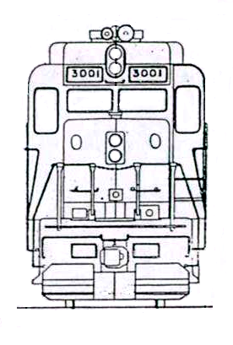

how to nominate
a property

TO THE

Colorado State Register
of Historic Properties

© 2015
History Colorado
1200 Broadway
Denver, CO 80203

PREFACE

This publication explains how to prepare a property nomination for the Colorado State Register of Historic Properties.

This publication was partially funded by the State Historical Fund, a grants program of History Colorado.



The cover image is a front-view drawing of the 3001-3028 series of Denver & Rio Grande Western GP30 type diesel-electric locomotive. No. 3006 is a rare surviving example of this second-generation diesel road switcher series that remains in near original operating condition. General Motors Corporation constructed the locomotive in 1962. Locomotive No. 3006 was listed in the
State Register in 2000.

A Preservation Program of the



Table of Contents

Nomination Form Sections

Section I 1

Section II 2

Section III. 3

Section IV. 7

Section V. 12

Section VI. 13

Section VII. 13

How to Nominate a Property

to the

Colorado State Register of Historic Properties

Any person or organization may prepare a State Register nomination. This includes property owners, public agencies, private institutions, local historical societies, local preservation commissions, local planning offices, social or merchant organizations, professional consultants, college professors and their students, special interest groups, or interested members of the general public. However, a nomination may not be processed without the written consent of the property owner. This includes both private and public owners. In the case of properties with multiple owners, the consent of all owners is required.

Completing the Nomination Form

Please type the form and complete each blank. Nomination forms are available in digital format. The State Register office can more easily edit your nomination if you submit a digital copy using any PC-compatible word processing software. Nomination forms and related materials are available on the Internet through the Office of Archaeology and Historic Preservation (OAHP) at www.coloradohistory-oahp.org. It is a good idea to discuss your nomination with the State Register staff before beginning.

SECTION I

Name of Property

The historic name is generally the name associated with the significance of the property. For a building this is usually the name of the original owner or builder, the original business, the original use or the most significant use of the property. Residences without a formal name are often referred to by the original owner or the most prominent owner (e.g., Charles Boettcher Mansion).

Other names may reflect the property's history, ownership, or use. Therefore, it may be appropriate to list several names, including the current property name. For archaeological properties, it is important to list all the known names.

Address of Property

Give the current street address of the property. In the case of archaeological or rural properties, give the names of the closest roads or highways, and the nearest city or town. Use "vicinity of" before the town name. You may place a check in the box if you do not want the property's address to be published.

Present Owner of Property

Give the name, address, and phone number of the present owner(s) of the land and property. Attach a continuation sheet in the case of multiple ownership of the nominated property.

Owner Consent

In order to be nominated to or listed in the State Register, all the owners of the land and property must consent to the listing by signing an owner consent form. Please photocopy additional consent forms if necessary. All completed forms submitted must contain original signatures.

Proof of ownership is required for all properties nominated to the State Register. This proof may be obtained from county land recordation records (county clerk's office) or tax assessor's records. The exact document available will vary by county, but it must be from an official record with the source clearly shown. The copy must be dated by the issuing agency and should be obtained as near to the nomination submission date as possible.

Preparer of Nomination

Give the name, address, and phone number of the person preparing the nomination. Enter the date the form was completed. Also include the name of the organization to which the preparer is affiliated, if applicable.

SECTION II

Local Historic Designation

Indicate if a property has been locally designated and whether it is an individual listing or within a historic district. Enter the date the property received official designation and the name of the municipality or county making the designation.

Use of Property

Give all the past (historic) and current uses of the property.

Original Owner

Historical research is usually required to locate the name of the original owner of a property. The name may be found in an abstract included with the deed and title documents or may be found by tracing the chain of title at the local courthouse. Other sources may be tax assessor records, local newspaper articles, city directories or other public records. Indicate the name of the agency, document, or the name and date of the publication where the information was found.

Year of Construction

Give the year the original construction was completed for buildings, structures, and objects. For districts, give a range of dates beginning with the earliest construction and ending when the majority of construction within the district was completed. Indicate the name of the agency, document, or the name and date of the publication where the information was found. For archaeological properties, include estimated dates of construction or use and indicate dating source(s).

Architect, Builder, Engineer, Artist or Designer

This information may be available at the local building department, tax assessor’s office, water department or in local newspaper articles. Indicate the name of the agency, document, or the name and date of the publication where the information was found.

Locational Status

Indicate if a building or structure has been moved. If moved, provide the date of the move.

SECTION III

Description of the Property

Use one or more continuation sheets to describe the present and original (if known) physical appearance of the nominated property, and to describe and date known alterations. Discuss the exterior and interior features of the building or structure, as well as the landscaping and the setting. For historic and archaeological sites, describe the features of the site and the setting.

There are a number of architectural dictionaries available in local libraries which will help you prepare an accurate architectural description. The style guides recommended on page 11 may also be useful here. Recommended are:

Dictionary of Architecture and Construction by Cyril Harris (New York: McGraw-Hill, 2005).

Dictionary of Building Preservation by Ward Bucher, ed. and Christine Madrid ed. (New York: John Wiley and Sons, 1996).

Old House Dictionary by Stephen Phillips (Washington DC: Preservation Press, 1994).

Visual Dictionary of American Domestic Architecture by Rachel Carley (New York: Henry Holt & Co., 1994).

The State Register program is patterned on the National Register of Historic Places. You may find it helpful to look at the National Register instruction book for details and examples relevant to the State Register forms. The National Register instructions may be obtained from the State Register staff. The document is entitled: How to Complete the National Register Registration Form. The document is also available on the OAHP Website at: coloradohistory-oahp.org/publications/bulletins.htm.

Contact the State Register staff if you have questions or need help with the property description.

The following types of information should be included in your description based on the property classification:

Historical and Architectural Nominations

Buildings, Structures and Objects
Describe the building or structure in a logical sequence. Begin with a brief overview of the setting. Then describe each building from the foundation up and from side to side around the exterior; work from the exterior to the interior. Clearly distinguish between the current and the original (if known) appearance of the property.

• Associated landscaping and environmental settings along with other historic or intrusive elements that are part of the nomination.

• General characteristics of the nominated property such as overall shape of plan; number of stories; construction materials; and roof shape.

• Specific features (placement of porches, windows, doors, chimneys and dormers).

• Important decorative elements.

• Major interior features (note any original features such as stairways, trim and molding, fireplaces and mantles, or lighting fixtures).

• Descriptions of all buildings on the property, both historic and recent construction. Briefly describe minor buildings and provide dates of construction. This includes garages, sheds, barns, privies, and other outbuildings.

• Alterations to the property over time. Describe and give the dates of all exterior changes and any significant interior changes to the building or structure. Changes include additions, removal of features (such as stairways, fireplaces, walls or porches), and changes in window or door sizes and placement. A restoration is considered an alteration even if an attempt has been made to restore the property to its historic form. It is often helpful to include a sketch of the property which shows original construction and subsequent alterations/additions (see Figure 1).

Districts

When nominating a district for its architectural or historical significance, include the following information:

• General overall description of the natural and man-made elements of the district.

• Number of buildings, structures and/or objects in the historic district. For archaeological districts, give the number of sites and/or features.

• General description of the types, styles, and periods of architecture in the district. Include predominant construction materials.

• List of all buildings, regardless of age, with dates of construction and a short description of each. Key the buildings to a sketch map.

Archaeological Nominations

Archaeological Properties

The description for prehistoric or historic archaeological properties should include the following information:

• Environmental setting of the property today and, if different, its environmental setting during the periods of occupation or use. Emphasize environmental features or factors related to the location, use, formation, or preservation of the site.

• Period of time when the property is known or projected to have been occupied or used. Include comparisons with similar sites and districts that have assisted in identification.

• Identity of the persons, ethnic groups, or archaeological cultures who, through their activities, created the archaeological property. Include comparisons with similar sites and districts that have assisted in identification.
Figure 1
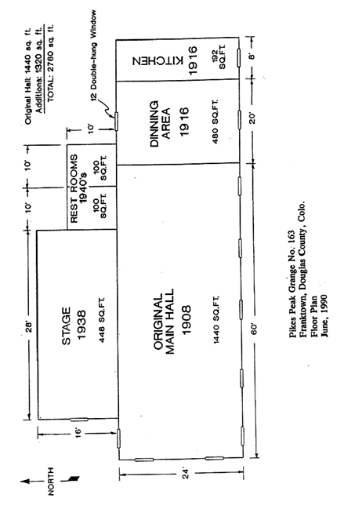
• Physical characteristics:

1. Site type, such as rockshelter, temporary camp, lithic workshop, rural homestead or shoe factory.
2. Prehistorically or historically important standing structures, buildings or ruins.
3. Kinds and approximate number of features, artifacts, and ecofacts, such as hearths, projectile points, and faunal remains.
4. Known or projected depth and extent of archaeological deposits.
5. Known or projected dates for the period when the site was occupied or used, with supporting evidence.
6. Vertical and horizontal distribution of features, artifacts, and ecofacts.
7. Natural and cultural processes, such as flooding and refuse disposal, that have influenced the formation of the site.
8. All buildings, structures, and objects within the site.

• Likely appearance of the site during the periods of occupation or use. Include comparisons with similar sites and districts that have assisted in description.

• Current and past impacts on or immediately around the property, such as modern development, vandalism, road construction, agriculture, soil erosion, or flooding.

• Previous investigations of the property, including:

1. Archival or literature research.
2. Extent and purpose of any excavation, testing, mapping, or surface collection.
3. Dates of relevant research and field work. Identity of researchers and their institutional or organizational affiliation.
4. Important bibliographic references.

Archaeological Districts

• Environmental setting of the district today and, if different, its environmental setting during the periods of occupation or use. Emphasize environmental features or factors related to the location, use, formation, or preservation of the district.

• Physical characteristics:

1. Type of district, such as an Indian village with outlying sites, a group of quarry sites or a historic manufacturing complex.
2. Cultural, historic, or other relationships among the sites that make the district a cohesive unit.
3. Kinds and number of sites, structures, buildings, or objects that make up the district.
4. Information on individual or representative sites and resources within the district (see Archaeological Properties above). For small districts, describe individual sites. For large districts, describe the most representative sites individually and others in summary or tabular form or collectively as groups.
5. All buildings, structures, and objects within the district.

• Period of time when the district is known or projected to have been occupied or used. Include comparisons with similar sites and districts that have assisted in identification.

• Identity of the persons, ethnic groups, or archaeological cultures who occupied or used the area encompassed by the district. Include comparisons with similar sites and districts that have assisted in identification.
• Likely appearance of the district during the periods of occupation or use. Include comparisons with similar sites and districts that have assisted in description.

• Current and past impacts on or immediately around the district, such as modern development, vandalism, road construction, agriculture, soil erosion, or flooding. Describe the integrity of the district as a whole and, in written or tabular form, the integrity of individual sites.

• Previous investigations of the property, including:

1. Archival or literature research.
2. Extent and purpose of any excavation, testing, mapping, or surface collection.
3. Dates of relevant research and field work. Identity of researchers and their institutional or organizational affiliation.
- Important bibliographic references.

SECTION IV

Significance of the Property

A property considered for nomination must meet one or more of the following criteria. Please check the appropriate criterion on the form. Remember that each criterion chosen must be justified in the Statement of Significance.

Nomination Criteria

A The property is associated with events that have made a significant contribution to history; or

B The property is connected with persons significant in history; or

C The property has distinctive characteristics of a type, period, method of construction or artisan; or

D The geographic importance of the property; or

E The property contains the possibility of important discoveries related to prehistory or history.

Criterion A - To be considered for nomination under Criterion A, a property must have an historical association with a single event, such as the founding of a town, or with a pattern of events that were important in the history of the locality, state, or nation. Evaluate the history of the property to determine its association with any of these events. It must be documented through historical research that the property existed at the time of the event(s) and was associated with those events in some significant way.

Criterion B - This criterion applies to properties associated with an individual whose contribution to history was significant and can be documented. The property also needs to be associated with the person's productive life when the person achieved importance. The property should have a documented association with the person, such as an office, home or studio, but should not be a property merely owned or briefly visited by the prominent person or one which does not represent the productive period in that person's life.
Criterion C - Properties nominated under Criterion C are generally significant for their architecture and must be physically intact with a minimum of alterations. Buildings may qualify under this criterion if they have artistic merit in design or individual elements. In addition to architecture, other areas of significance under this criterion are engineering, community planning and development, art and landscape architecture.

If the building represents the work of an artisan, it would qualify under Criterion C and not B. An artisan can be a prominent architect or a craftsman (either known or anonymous) whose work is distinguishable from others.

A building nominated for a particular architectural style must possess the distinctive characteristics which make up that particular style. A building may also qualify if it can be demonstrated that the building exemplifies important local building practices, techniques, or materials. A property which illustrates an early or developing technology in structural systems may be eligible as an
example of a particular method of construction. Archaeological architectural features must be intact enough to retain information concerning construction methods and materials.

Criterion D - The geographic importance of a property refers to its location. A building or structure commonly recognized as a visual landmark due to its prominent location may qualify under Criterion D. A lighthouse has geographic importance as does a fire look-out tower. A park in the center of town and a cemetery on top of a hill may also have geographic importance. For a property to be nominated under Criterion D it must also possess physical integrity with a minimum of alterations.

Criterion E - Certain important research questions about human history can only be answered by the actual physical material of cultural resources. The most common type of property nominated under Criterion E is the prehistoric or historic archaeological site. However, buildings, structures, and objects may also be eligible for their information potential. Properties nominated under Criterion E must meet two requirements: the property must have, or have had, information that contributes to our understanding of history or prehistory, and that information must be considered important.

Areas of Significance

Select one or more areas of significance from the list below in which the property qualifies for listing based on the nomination criteria. Check the areas on the form. Remember that each area of significance selected must be justified in the Statement of Significance.

Agriculture
Architecture
Archaeology - prehistoric Archaeology - historic
Art
Commerce
Communications
Community Planning and
Development
Conservation
Economics
Education
Engineering
Entertainment/Recreation
Ethnic Heritage
Exploration/Settlement
Geography/
Community Identity
Health/Medicine
Industry
Invention
Landscape Architecture
Law
Literature
Military
Performing Arts
Politics/Government
Religion
Science
Social History
Transportation

In the case of properties having archaeological significance, enter areas of significance that closely relate to the events, activities, characteristics, or information for which the property is significant, for example, "industry" for a prehistoric tool-making site.

For more information regarding significance, see the State Register bulletin, How to Apply the Nomination Criteria for the Colorado State Register of Historic Properties. This publication is available in hard copy from the State Register staff or it may be viewed on the Web at: coloradohistory-oahp.org/publications/bulletins.htm.

Historic Integrity

In addition to meeting the criteria listed above, a property must have retained its historic physical integrity. Integrity can best be defined as the ability of a property to convey its history and significance. The evaluation of integrity is sometimes a subjective judgment, but it must always be grounded in an understanding of a property's physical features and how they relate to its significance.

Historic properties either retain integrity (i.e., convey their significance) or they do not. Within the concept of integrity, the State Register criteria recognize seven aspects or qualities that, in various combinations, define integrity.

To retain historic integrity a property will always possess several, and usually most, of the aspects. The retention of specific aspects of integrity is paramount for a property to convey its significance. Determining which of these aspects are most important to a particular property requires knowing why, where and when the property is significant.

Seven Aspects of Integrity

1. Location is the place where the historic property was constructed or the place where the historic event occurred.

2. Setting is the physical environment of a historic property.

3. Design is the combination of elements that create the form, plan, space, structure, and style of a property.

4. Materials are the physical elements that were combined or deposited during a particular period of time in a particular pattern or configuration to form a historic property.

5. Workmanship is the physical evidence of the crafts of a particular culture or people during any given period in history or prehistory.

6. Feeling is a property's expression of the aesthetic or historic sense of a particular period of time.

7. Association is the direct link between an important historic event or person and a historic property.

Assessing Integrity in Properties

Remember, only after significance is fully established can you proceed to the issue of integrity.
The steps in assessing integrity are:

• Define the essential physical features that must be present for a property to represent its significance;

• Determine whether the essential physical features are visible enough to convey their significance;

• Determine whether the property needs to be compared with similar properties; and,

• Determine, based on the significance and essential physical features, which aspects of integrity are particularly vital to the property being nominated and if they are present.

Ultimately, the question of integrity is answered by whether or not the property retains the identity for which it is significant.

For more information regarding integrity, see the State Register bulletin, How to Apply the Nomination Criteria for the Colorado State Register of Historic Properties. This publication is available in hard copy from the State Register staff or it may be viewed on the Web at: http://www.historycolorado.org/sites/default/files/files/OAHP/crforms_edumat/pdfs/960.pdf

Significance Statement

Using continuation sheets make the case for the property's significance. Additional information may be attached to the form but this information cannot serve as a substitute for providing the justification of the property's significance on the nomination form. The narrative should be concise, factual, and well-organized.

Be selective in the facts you present. Consider whether the facts really support the significance of the property. Focus only on those facts that help explain the property's role in history and that illustrate its significance. Be specific about dates and proper names of people and places.

Begin with a summary paragraph that simply and clearly states the criteria and areas of significance met by the property and why these criteria apply.

Subsequent paragraphs should include the following:

• Brief historical overview of the area, community, or town;

• Brief chronology of the historic development of the property;

• Relation of the property's history to the overall history of the area—relate the property to important themes (such as education, agriculture, or mining,) in the area's history; and,

• Support of each area of significance demonstrated through a discussion of the facts and circumstances in the property's history that leads to its importance.

For archaeological properties, the following specific questions should also be addressed:

• What is the cultural context in which the property is considered significant? How does the site relate to what is currently known of the region's prehistory or history and similar known sites?
• What kinds of information can the known data categories yield? What additional kinds of information are expected to be present on the basis of knowledge of similar sites? What similarities permit comparison with other known sites?

• What is the property's potential for research? What research questions may be addressed at the property? How do these questions relate to the current understanding of the region's archaeology? How does the property contribute or have the potential for contributing important information regarding human ecology, cultural history, or cultural process? What evidence, including scholarly investigations, supports the evaluation of significance? Given the existence of material remains with research potential, what is the context that establishes the importance of the recoverable data, taking into account the current state of knowledge in specified topical areas?

• How does the integrity of the property affect its significance and potential to yield important information?

• If the site has been totally excavated, how has the information yielded contributed to the knowledge of American cultures or archaeological techniques to the extent that the site is significant for the investigation that occurred there?

• Does the property possess resources, such as buildings or structures, that in their own right are architecturally or historically significant? If so, how are they significant?

For those needing guidance on conducting historical research, the National Register has produced a helpful bulletin, Researching a Historic Property. This publication is available in hard copy from the State Register staff or it may be viewed on the Web at: coloradohistory-oahp.org/publications/
bulletins.htm.

In the case of properties significant for their architecture, there are a number of architectural style books available at local libraries which will help in the identification and evaluation of your building. These books and others may be used at the Office of Archaeology and Historic Preservation at the Colorado History Museum, 1300 Broadway, in Denver. Recommended volumes include:

Field Guide to American Houses by Virginia and Lee McAlester (New York: Alfred A. Knopf, 1984).

A Guide to Colorado’s Historic Architecture and Engineering by the Office of Archaeology and Historic Preservation (Denver: History Colorado, 2003). This publication is also available on the Web at: http://www.historycolorado.org/oahp/colorados-historic-architecture-engineering-field-guide

What Style is It? by John Poppeliers, S. Allen Chambers, and Nancy B. Schwartz (Washington, DC: Preservation Press, 1977).

Identifying American Architecture by John Blumenson (Nashville: American Association for State and Local History, 1981).

For engineering structures such as bridges, local libraries may have a number of publications that provide information on specific structural types.
Bibliography

Using a continuation sheet, list the research sources used in documenting and evaluating the property and in preparing this form. Use a standard bibliographical style. For all printed materials, list the author, full title, publisher, location, and date of publication. For articles, include the name, volume, and/or date of the journal or magazine. For unpublished manuscripts, indicate where copies are available. For interviews, include the name of the person interviewed, the name of the interviewer, the date and location of the interview, and the location where the tape or transcript is stored.
Examples of bibliographical entries:

(for books)
Athearn, Robert G. The Coloradans. Albuquerque: Univ. of New Mexico Press, 1976.

(for magazines)
Evans, Robert. "Pioneers of El Paso County”, Colorado Magazine, July 1992, pp.14-16.

(for newspaper articles)
"Smith House Restored." Denver Post, 25 May 1965, p. 2.

(for personal interviews)
Downing, John D. Interview, 12 May 1962, by Joe Brown at the Craig City Library. Transcript filed at Craig City Library.

SECTION V

Geographical Data

Locational Information

For urban properties, give the lot, block, and the addition name. This information may be obtained through the local tax assessor’s office.

For all properties, note the name of the United States Geological Survey (USGS) quadrangle map on which the property is located. A section of this map with the location of the nominated property must be included with the nomination. (See page 16 for more information.)

Verbal Boundary Description of Nominated Property

Describe the proposed boundaries of the nominated property on one or more continuation sheets. The description must be accurate and precise. Use one of the following forms:

• A legal parcel number.

• A block and lot number.

• A sequence of metes and bounds.

• Dimensions of a parcel of land fixed upon a given point such as the intersection of two streets, a natural feature, or a manmade structure.
• A map drawn to a scale of at least 1 inch = 200 feet may be substituted for a narrative verbal boundary description. Reference to the map should be made in this section.

SECTION VI

Photograph Log for Black and White Photographs

Prepare a photograph log similar to the one shown below containing the indicated information. For traditional film prints, indicate the storage location of the negatives. For digital prints, indicate the type of ink and paper used. See Section VII for more information about photograph print options.

PHOTOGRAPH LOG

The following information pertains to photographs numbers 1-12, except as noted:

Name of Property: Jones Cabin
Location: Springdale, Larimer County
Photographer: F. Stop Fitzgerald
Date of Photographs: 12/17/2003
Location of Negatives: Springdale History Museum, Springdale
Or Type of Ink: Epson UltraChrome pigmented
Type Paper: Epson Enhanced Matte

Photo No. Description of View and Direction of Camera
1 Cabin facade, view to the south.
2 West elevation, view to the southeast.

SECTION VII

Official Nomination Photographs

Photographs submitted as official documentation to the State Register program are expected to last 75 years or longer before showing significant signs of fading, deterioration, or discoloration. Black-and-white prints have been required since the inception of the program because of their superior permanence. While the State Register continues to accept conventional black and white photographs, digital images produced by methods demonstrated to meet the 75-year permanence standard are also acceptable. The State government does not endorse any particular commercial product or process.

Traditional Film Prints
A 75-year-permanence standard is intended to ensure the longevity of State Register documentation and applies to all forms of photodocumentation, including those types of photographs currently available and any introduced in the future. Black-and-white images printed on silver-emulsion fiber-based papers and black-and-white images printed on silver-emulsion resin-coated (RC) papers have been acceptable for some time.

Prints made from black-and-white film using C-41 color processing are acceptable if printed on a high quality, stable paper. Fujicolor Crystal Archive or equivalent paper by other manufacturers is acceptable.
Digital Images

As of this writing, black-and-white and color prints produced from digital images that have been demonstrated to meet or exceed a 75-year permanence standard also are acceptable. Prints produced from digital photographs submitted as official documentation must be accompanied by corresponding electronic image files. Ideally, electronic image files should be saved as uncompressed .TIF (Tagged Image File format) files on CD-R media, in keeping with guidance on digital photographic records issued by the U.S. National Archives and Records Administration. The size of each image should be 1600x1200 pixels at 300 ppi (pixels per inch) or larger. It is recommended that digital images be saved in 8-bit (or larger) color format, which provides maximum detail even when printed in black-and-white. When in doubt as to the image size generated by a camera, capture the images at the highest resolution possible.

The file name for each electronic image saved on the CD-R must correspond with the photo log included in the nomination and the number on the back of each photograph. For example, the image files for the James Smith House would be saved as “Smith1.tif”, “Smith2.tif”, and so forth.
CD-Rs submitted with a nomination must be labeled with the name of the property.

Digital Prints
Several options are available for those preparing nominations who wish to submit photographic prints produced from digital images. Consulting a photo lab in your area that offers professional services is a good starting point. A number of commercial processing methods produce high-quality prints from digital images that meet the State Register standards.

Prints may be produced with an inkjet or dye-sublimation photo printer that can use special archival inks and photo papers. While most photo printers made for the consumer market are designed to produce color prints that last only a few years before fading, a number of manufacturers now offer models which, with the correct inks and papers, can produce prints with an expected lifespan comparable to or better than traditional black-and-white prints on RC paper.

Acceptable Ink and Paper Combinations for Digital Images
The non-comprehensive list below includes products that meet the State Register permanence standard. Specific printers are not identified, as the longevity of a print is dependent on the ink and paper combinations used to produce it, rather than on the printer.

Ink Type | Paper Type
Epson UltraChrome pigmented inks | Epson Premium Glossy Paper
 | Epson Premium Semigloss Photo Paper
 | Epson Premium Luster Photo Paper
 | Epson Premium Semimatte Photo Paper
 | Epson UltraSmooth Fine Art Paper
 | Somerset Velvet for Epson
 | Epson Velvet Fine Art Paper
 | Epson Textured Fine Art Paper
 | Epson Enhanced Matte Paper
Epson Picture Mate inks | Epson PictureMate Photo Paper
Ink Type | Paper Type
Hewlett-Packard (HP) 84/85 dye-based inkset | HP Premium Plus Photo and Proofing Gloss
 | HP Premium Plus High Gloss Photo Paper
 | HP Premium Plus Soft Gloss Photo Paper
 | HP Premium Photo Paper, Gloss
 | HP Premium Photo Paper, Soft Gloss
Hewlett-Packard 59 gray photo cartridge | HP Premium Plus and HP Premium Photo Papers (high gloss, glossy and soft gloss)
Hewlett-Packard 100 gray photo cartridge | HP Premium Plus and HP Premium Photo Papers (high gloss, glossy and soft gloss)
Hewlett-Packard Vivera inks (95 and 97  tri-color cartridges) | HP Premium Plus and HP Premium Photo Papers (high gloss, glossy and soft gloss)

Basic Photograph Requirements
Photographs must be:
- unmounted (do not affix photographs to archival paper or any other material using staples, paper clips, glue, or other means; submit photos loose in an envelope).
- at least 4 x 6 inches.
- properly processed and thoroughly washed.
- labeled in pencil with only the photograph number.
Photographs with adhesive labels will not be accepted. The labels will eventually deteriorate and detach from the photograph, and their acidity may cause damage. Photographs that are improperly processed or incorrectly labeled will be returned.

Special note on date-imprinted photographs: Many cameras will automatically imprint the date on the face of each photograph. If you use such a camera, be certain that the date is correct. Incorrect date imprints provide a confusing historical record. Photographs with date imprints which do not correspond to the actual date the photographs were taken will not be accepted for nomination purposes.

Guidelines for Photographic Coverage
Photographs submitted to the State Register as official documentation should be clear, well-composed, and provide an accurate visual representation of the current appearance and condition of the property and its significant features. They must illustrate the qualities discussed in the description and statement of significance. Photographs should show historically significant features and also any alterations that have affected the property’s historic integrity.

The necessary number of photographic views depends on the size and complexity of the property. Submit as many photographs as needed to depict the current condition and significant features of the property. A few photographs may be sufficient to document a single building or object. Larger, more complex properties and historic districts will require a number of photos. Prints of historic photographs may supplement photodocumentation and be particularly useful in illustrating changes that have occurred or the lack of change over time.

Buildings, structures, and objects:
- Submit photographs showing all sides of each building or major feature and the setting in which the property is located.
- Additions, alterations, intrusions and dependencies should appear in the photographs.
- Include views of interiors, outbuildings, landscaping or unusual features if they contribute to the significance of the property.

Historic and archeological sites:
- Submit photographs showing the condition of the site and any above-ground or surface features and disturbances.
- If relevant to the evaluation of significance, include drawings or photographs illustrating artifacts that have been removed from the site.
- At least one photograph must show the physical environment and topography of the site.

Architectural and historic districts:
- Submit photographs showing major building types and styles, pivotal buildings and structures, and representative intrusive resources.
- Streetscapes and landscapes are recommended. Aerial views may also be useful. Views of significant topographic features and spatial elements should also be submitted.
- Views of individual buildings are not necessary if streetscape views clearly illustrate the significant historical and architectural qualities of the district.
- Key all photographs to the sketch map for the district.

Archeological districts:
- Submit photographs of the principal sites and site types within the district following the guidelines for archaeological sites (see above).

Color Images for Review Board Electronic Presentation

Each nomination is introduced at the Review Board meeting by the State Register staff by means of an electronic presentation. Color images of the nominated property are used in the presentation. If you submit color digital images as the official nomination photographs, no additional images are needed.

If you submit traditional film prints, then additional color images on a CD must be submitted for the board presentation. Submit 3 to 6 color prints, 4” x 6” or larger. Provide overall views of the property as well as any important exterior or interior details. For districts or complex properties, additional images will be necessary to adequately present the property to the Review Board.

Additionally, for the Review Board review of the nomination prior to the Review Board meeting, please submit one set of the photos via a PDF document with two photos per page. This must be submitted with the nomination packet on the nomination deadline. See attachment A for a sample.

Directions for labeling the images:

• Number the back of each print and create a photo log as described above for black & white photographs.

Photocopy of U.S. Geological Survey Topographic Map

Include a photocopy of that portion of a USGS 7.5 minute series (1:24,000 scale) topographic quad map that shows the location of the nominated property. The property location and the name of the quad map should be clearly marked on the photocopy. USGS maps may be available through a city or county planning office or local map retailers. Quad maps may also be purchased directly from the USGS via the Internet. Topographic quad map sections may be downloaded from several Websites, including TopoZone.com and Terraserver-usa.com. The USGS maintains a list of online map sources at http://nationalmap.gov/gio/viewonline.html.

Sketch Map

Provide a sketch map showing the location of buildings and other features. The map may be hand drawn and need not be to scale, but should identify the following:

• The proposed nomination boundaries;

• The names of streets and places;

• All buildings, sites, structures and objects;

• Land use and natural features for rural areas (woods, orchards or bodies of water); and,

• A north arrow.

See Figure 2 for an example of a sketch map for a historic property. It is helpful to show the boundaries of the nominated property on a photocopy of a tax assessor's map or other map that is to scale.

See Figure 3 for an example of a sketch map for an archaeological property.

Sketch Plan

A sketch plan of an individual building can be helpful if it shows original construction and subsequent alterations/additions (see Figure 1).

Optional Information

You may submit any other information which might be helpful in considering the eligibility of the property. However, this material is not a substitute for providing the requested information on the nomination form. Optional materials may include:

• Newspaper clippings

• Brochures

• Photocopies of historic photographs

Materials submitted with the nomination will not be returned. Submit clear copies of any original items you wish to retain.

Use of Nomination Materials

Upon submission to the Office of Archaeology and Historic Preservation, all nomination forms and supporting materials, including photographs, become public records pursuant to CRS Title 24, and may be accessed, copied and used for personal or commercial purposes in accordance with state law

unless otherwise specifically exempted. History Colorado may reproduce, publish, display, perform, prepare derivative works, or otherwise use the nomination materials for History Colorado and/or State Register purposes.
Figure 2
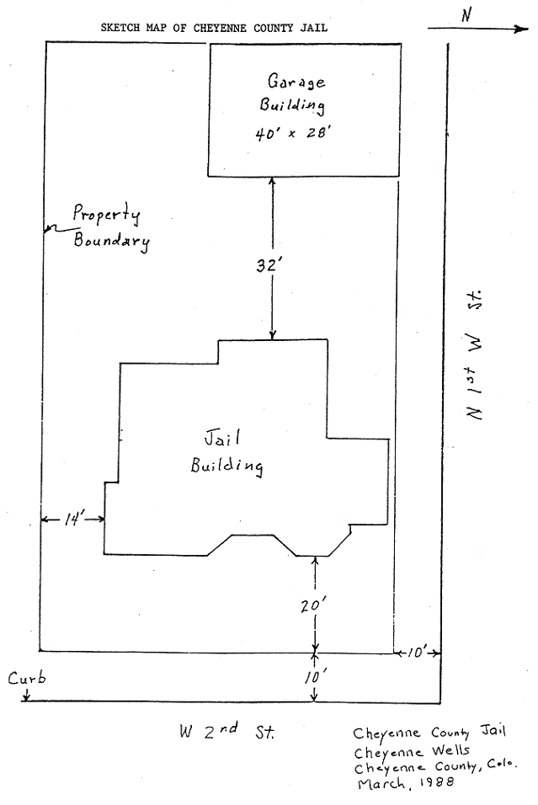
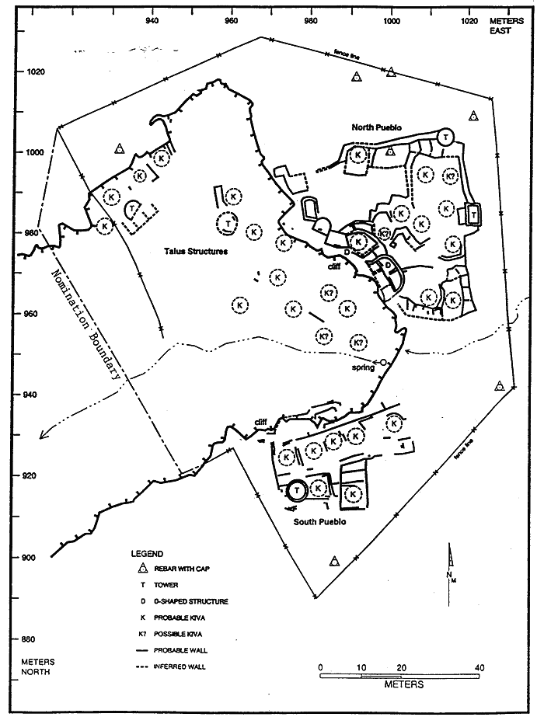
Figure 3

*******************

Completed nomination forms and supporting materials should be mailed to:

History Colorado
Attn. State Register
1200 Broadway
Denver, CO 80203

If you have questions, require assistance, or need additional forms, please call the State Register staff at 303-866-3392.

*******************

Moving State Register-Listed Properties

Every effort should be made to avoid moving a State Register-listed property. Such relocation may cause the property to lose its historical significance and be subject to removal from the Register. Contact the State Register staff if you are considering moving a State Register property. For additional information, see the State Register bulletin How to Amend Listings in the State Register.

Removing a Property from the State Register

Properties may be removed from the State Register if they lose those qualities which brought about their original listing. For more information, contact the State Register staff. For additional information, see the State Register bulletin How to Amend Listings in the State Register.
Attachment A – PDF document with photos and captions that correspond to the photo log

Current Photos
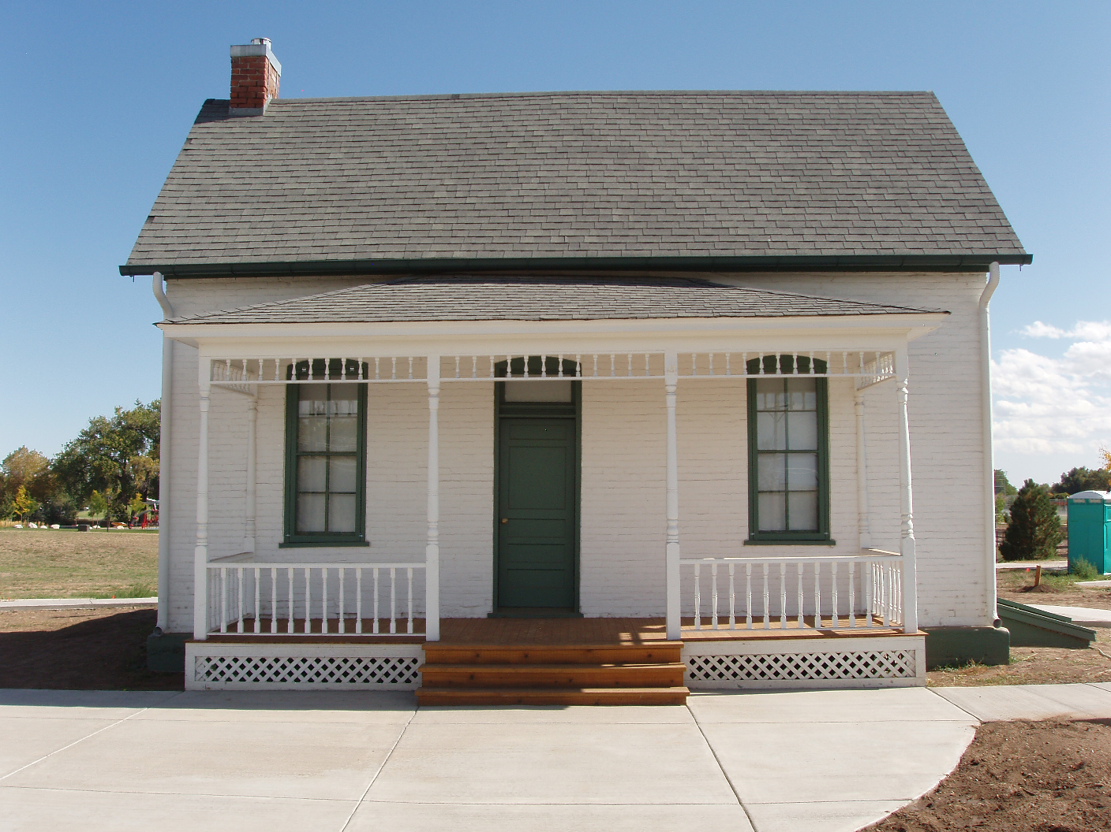
Photo 1 Southwest (main) Façade, camera facing northeast

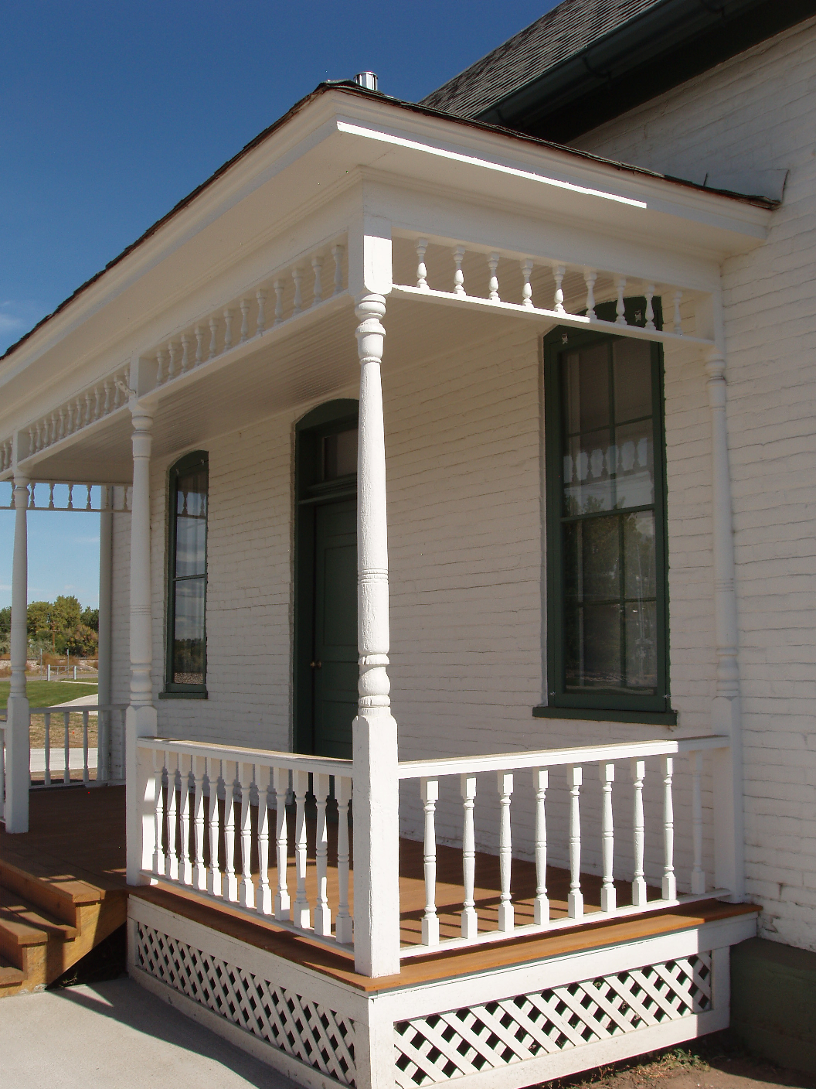
Photo 2 Southeast side of porch, camera facing northwest*

