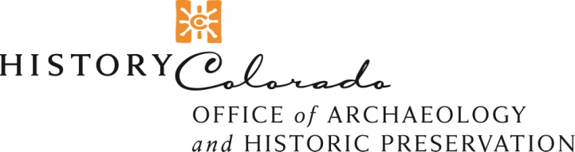

Colorado State Permit Application for Archaeological or Paleontological Work

- ARCHAEOLOGY or PALEONTOLOGY (please check one only)
- Date:
- Principal Investigator(s):
- Project Archaeologist(s)/Paleontologist(s):
- Institution/Company Name:
- Address:
- Primary contact person and email:
- Location of work to be performed (specify statewide, specific city/county, or actual locality):
- State: and/or Municipal/County: and/or Private: lands?
- Permit Type (click to select):
- Name, address & telephone number of landowner (excavations on private land):
- Nature of work to be carried out and reasons for carrying out research or field work:
- Planned use of data, and type of report and scientific publication:
- Plan for curation of materials and records (current curation agreement(s) are needed for most permits, see Rules & Regulations for more details):
Appendices: Append supporting information or continuations of the above information as appropriate.
**Append current vita(e) of Principal Investigator(s) and Project Archaeologists/Paleontologists.
**For excavation, append Research Design.
**Affidavits of Lawful Presence must be included for all individuals named on the permit application
(C.R.S. 24–76.5–103)
Check if you require a copy of “Rules and Procedures: Historical, Prehistorical and Archaeological Resources.”

Signature (PI) Title

By my signature, I affirm that all information provided for this application is true and that I understand my responsibilities as outlined in the Statute (1308a) and implementing regulations (1308b). False statements are punishable as perjury in the second degree. This notice is in accordance with section 18–8–501(2)(a)(I), C.R.S. Statute (1308a) and implementing regulations (1308b) viewable online at:
http://www.historycolorado.org/oahp/archaeology-and-paleontology-law-permits

Email application and questions to the Assistant State Archaeologist: Chris.Johnston@state.co.us (ALL COPIES of application and affidavit(s) must be signed).
Phone:(303) 866–4671
Mail: State Archaeologist, History Colorado, 1200 Broadway, Denver, CO 80203

